MULTI-LINE INSURANCE POLICY AND CLAIMS MANAGEMENT SYSTEM
College Name:K.S.K.College Of Engineering And Technology
College Code:8210

Department:Computer Science Engineering

Team ID:SWTID-2026-1795

S.No | Student Name | Register Number | NM-ID
01. | A.Anisha(TL) | 821023104004 | 18F58EB7D614AEDA77F4C4362DB65987
02. | D.Akalya | 821023104002 | 1411A5F254BFBE0BDAB4DCB22CDEE2BC
03. | G.Rashya | 821023104027 | 1EED42707366492B0734DE67FD02E1BB
04. | V.Shalini | 821023104034 | 22B8640085DAD5EB20A414D515CC3F

TABLE OF CONTENTS
- INTRODUCTION
Project Overview
Purpose
Project Objectives
- IDEATION PHASE
Problem Statement
User Personas
Empathy Map Canvas
Brainstorming and Idea Selection
- REQUIREMENT ANALYSIS PHASE
Customer Journey Map
Functional Requirements
Non-Functional Requirements
Data Flow
Technology Stack
- PROJECT DESIGN PHASE
Problem–Solution Fit
Proposed Solution
Solution Architecture
Data Model Design
Policy and Claim Decision Logic
- PROJECT PLANNING &SCHEDULING
Agile Planning
Product Backlog
Sprint Roadmap
Project Tracking
- PROJECT DEVELOPMENT PHASE
Salesforce Environment
Custom Objects
Fields and Relationships
Flow Design
Flow Implementation
Agentforce Configuration
Agentforce Action
Input and Output Contract
- FUNCTIONAL & PERFORMANCE TESTING
Test Strategy
Test Cases

Multi-Line Insurance Policy and Claims Management System | Page 2

Claim Validation
Agentforce Validation
Test Summary
- ADVANTAGES &DISADVANTAGES
- CONCLUSION
- FUTURE SCOPE
- APPENDIX

Multi-Line Insurance Policy and Claims Management System | Page 3

INTRODUCTION

Project Overview
Multi-LineInsurancePolicyandClaimsManagementSystemisaSalesforce-basedmanagementsolutiondesigned to organize multiple types of insurance policies and their related claims in a single controlled environment. The system maintains customer information, policy details, coverage, premium information and claim records while providing automation for routine policy and claim handling.
The system is designed around a central customer record and connected insurance records. A user can identify a customer, view active policies across different insurance lines, register a claim, validate basic policy conditions and receiveastructuredclaim-handlingresult.SalesforceFlowperformscontrolledbackendautomationandAgentforce can provide a conversational interface for requesting policy or claim assistance.

Purpose
    - Reduce repetitive manual policy and claim administration.
    - Maintain insurance information in a structured CRM environment.
    - Connect customers with multiple insurance lines such as health, motor, life and property.
    - Automate basic claim validation and status updates.
    - Provide a conversational interface for policy and claim enquiries.
    - Improve consistency of policy and claim processing.

Project Objectives

Objective | Expected Result
Customer Management | Maintain a central customer record.
Multi-Line Policy Management | Store and manage different insurance policies.
Policy Tracking | Track policy number, type, premium, coverage and dates.
Claim Management | Register and track claims against eligible policies.
Claim Validation | Check basic policy status and claim information.
Automation | Use Flow to perform controlled policy/claim actions.
Conversational Access | Allow Agentforce to provide policy and claim information.

Multi-Line Insurance Policy and Claims Management System | Page 4

IDEATION PHASE

Problem Statement
Insuranceorganizationsmanagecustomerswhomayholdmultiplepoliciesatthesametime.Policydetails,renewal dates, premium information and claims can become difficult to track when records are maintained through disconnected processes. Claim teams may also spend time checking policy status, coverage information and claim details before deciding the next action.

Stakeholder Need | Current Difficulty | System Response
Customer | Needs clear policy and claim information | Centralized customer view
Insurance Agent | Needs quick access to policy details | Structured policy records
Claims Officer | Needs consistent claim validation | Automated Flow checks
Manager | Needs visibility across insurance lines | Connected CRM records
Agentforce | Needs controlled backend action | Flow-based automation

User Personas

Persona | Main Goal | Interaction With System
Customer | Manage policies and claims | Provides policy/claim information
Insurance Agent | Maintain customer policies | Creates and updates policy records
Claims Officer | Process claims efficiently | Reviews validation and claim status
Manager | Monitor insurance operations | Views policy and claim information
Agentforce | Interpret user request | Collects details and invokes Flow

Empathy Map Canvas
    - Says: “I need to know my policy status and claim progress.”
    - Thinks: “Is my policy active and does my coverage apply?”
    - Does: Contacts an agent or submits a claim.
    - Feels: Concerned when claim processing takes time.
    - Needs: Clear status, policy coverage and next action.

Brainstorming and Idea Selection
Theideationconsideredmanualregisters,spreadsheets,standaloneportals,CRMautomationandconversational assistance. A Salesforce-based solution was selected because it can combine structured customer data, policy records, claims, Flow automation and Agentforce interaction in one environment.
    - Manual register – simple but highly dependent on human effort.
    - Spreadsheet tracking – easy to start but weak for controlled automation.
    - Standalone portal – improves interface but requires separate infrastructure.
    - Salesforce Flow – provides structured backend automation.
    - Salesforce + Agentforce – combines CRM data, automation and conversational interaction.

Multi-Line Insurance Policy and Claims Management System | Page 5

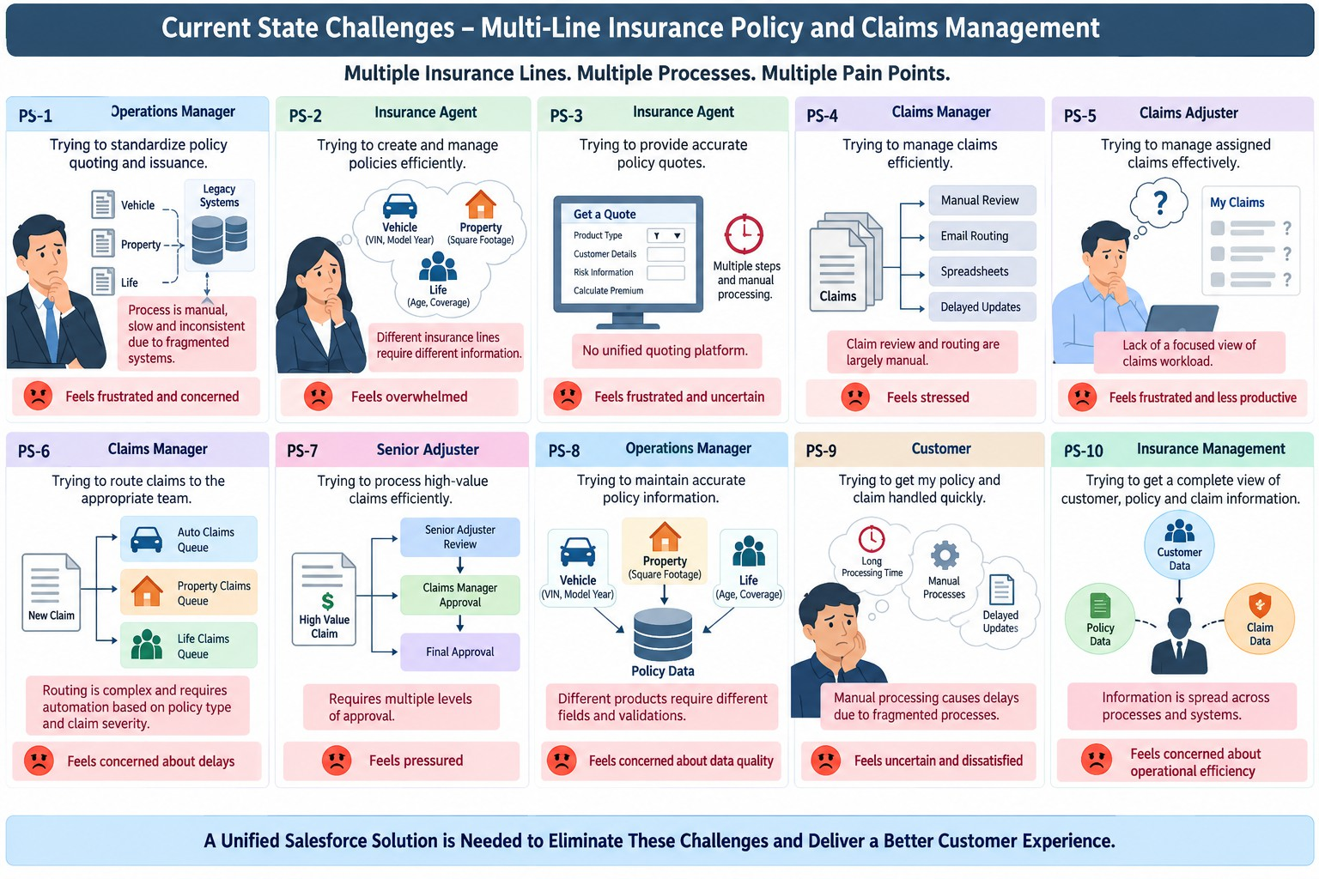

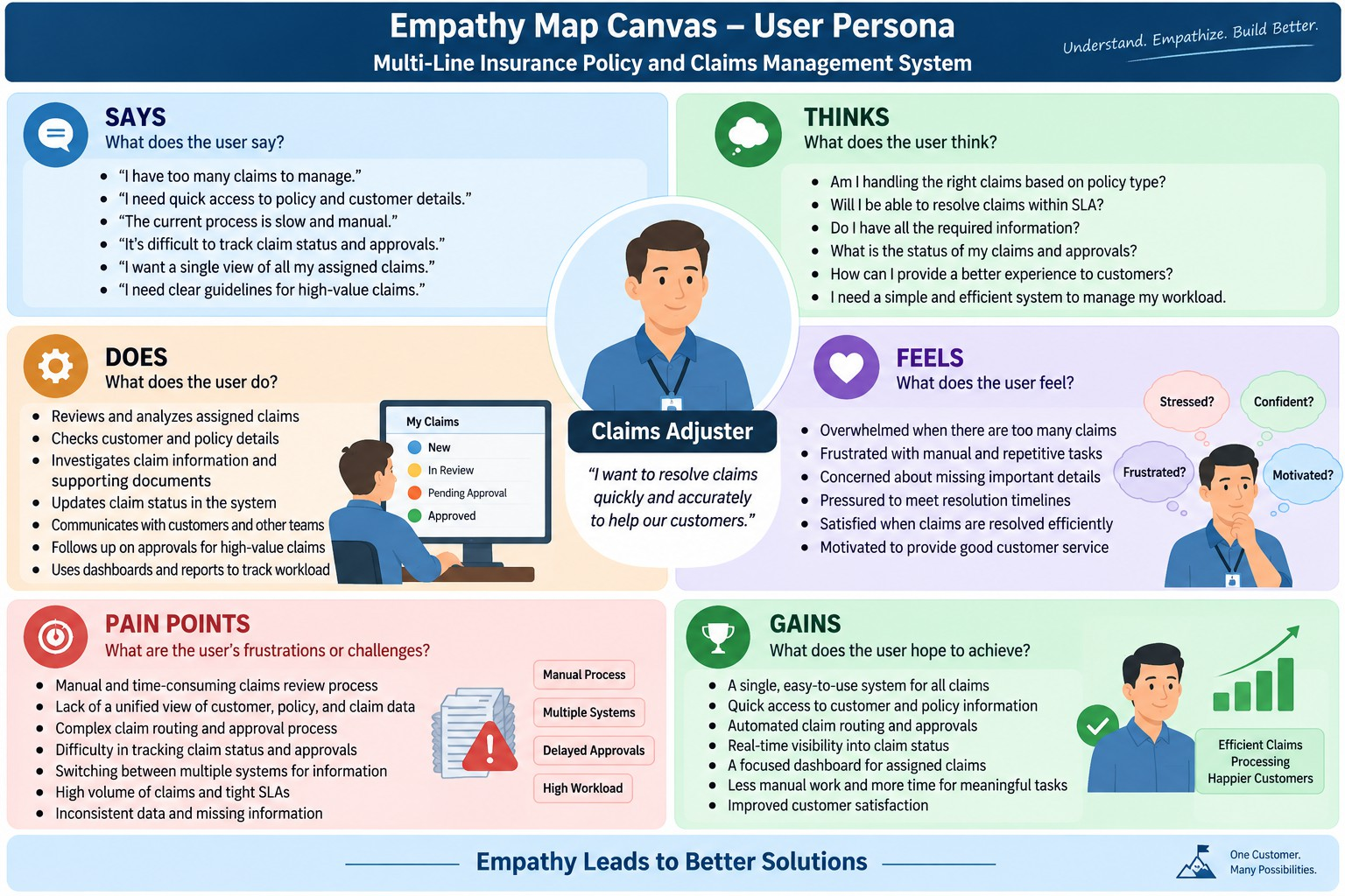

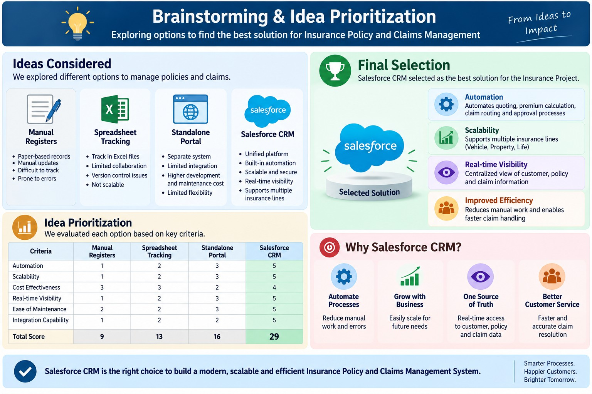

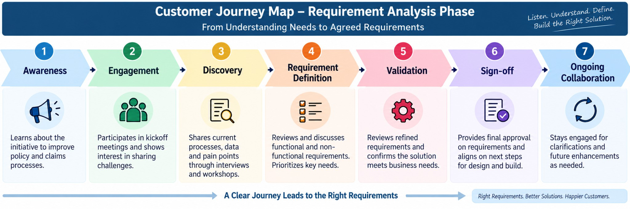

REQUIREMENT ANALYSIS PHASE

Customer Journey Map
Thecustomerjourneybeginswithcustomeridentification,followedbypolicylookup,claimregistrationwhenrequired, policy eligibility checking, claim validation and a final status or action message. Key automation checkpoints are customer retrieval, active-policy lookup, claim validation, status assignment and notification/action creation.

Functional Requirements

ID | Requirement | Description
FR-01 | Customer Management | Create and maintain customer records.
FR-02 | Policy Management | Create and maintain multiple insurance policies.
FR-03 | Policy Association | Associate policies with a customer.
FR-04 | Policy Lookup | Find active or relevant policies for a customer.
FR-05 | Claim Registration | Create a claim against a policy.
FR-06 | Claim Validation | Check basic policy status and required claim information.
FR-07 | Claim Status | Return Submitted, Under Review, Approved, Rejected or Settled.
FR-08 | Agent Assignment | Return the configured claims handling level.
FR-09 | Agentforce Interaction | Allow conversational policy and claim requests.
FR-10 | Renewal Check | Identify policies approaching renewal.

Non-Functional Requirements

Quality | Requirement
Usability | Screens and prompts should be understandable to users.
Reliability | Configured rules should produce consistent results.
Performance | Record lookup and Flow execution should complete quickly.
Security | Customer, policy and claim information should remain within controlled access.
Maintainability | Policy and claim rules should be easy to update.
Scalability | Design should support more customers, policies and claims.

Data Flow
User/Customer →Agentforce →Flow Input →Customer Lookup →Policy Lookup →Claim Lookup/Creation →
Eligibility & Claim Validation →Status/Assignment Action →Agentforce Response.

Technology Stack

Layer | Technology / Component
CRM Platform | Salesforce
Data | Customer, Policy, Claim, User, Task
Automation | Auto-Launched Salesforce Flow
AI Interface | Agentforce
Development | Salesforce DX / Salesforce CLI
Version Control | Git and GitHub

Multi-Line Insurance Policy and Claims Management System | Page 6

PROJECT DESIGN PHASE

Problem–Solution Fit

Problem Area | Designed Solution | Result
Scattered policy records | Centralized policy object | Single customer policy view
Multiple insurance lines | Line-of-business field | Health/Motor/Life/Property tracking
Manual claim checks | Flow-based validation | Consistent validation
Manual status updates | Automated status logic | Reduced repetitive work
Unclear customer interaction | Agentforce interface | Conversational access
Renewal risk | Renewal date check | Earlier attention to expiring policies

Proposed Solution
TheproposedsystemcombinesSalesforcecustomobjectsforCustomer,InsurancePolicyandInsuranceClaimwith Auto-Launched Flows and an Agentforce interface. Agentforce handles conversational interaction, while Flow performs controlled record retrieval, eligibility checks, claim validation, assignment and status updates.

Solution Architecture
Customerrecordsformtheprimarycontext.Eachcustomercanhavemultipleinsurancepolicies.Eachpolicybelongs to one insurance line and can have multiple claims. Claims are processed through validation rules and Flow actions. Agentforce acts as the conversational entry point and invokes the relevant backend Flow.

Data Model Design

Record | Purpose | Relationship
Customer | Stores customer information | Parent of policies
Insurance Policy | Stores policy and coverage details | Linked to customer
Insurance Claim | Stores claim information | Linked to policy and customer
User | Stores assigned staff | Used for assignment
Task | Stores follow-up work | Created for selected claim actions

Policy and Claim Decision Logic
Thecurrentproposedlogicusesconfiguredbusinessconditionsratherthanatrainedmachine-learningclassifier.An active policy is considered eligible for basic claim processing when its status is Active, the claim date falls within the policy period and the selected coverage/insurance line is applicable. Claims with missing required information are returned for completion. Claims that pass basic checks move to Under Review or the configured next status.

Multi-Line Insurance Policy and Claims Management System | Page 7

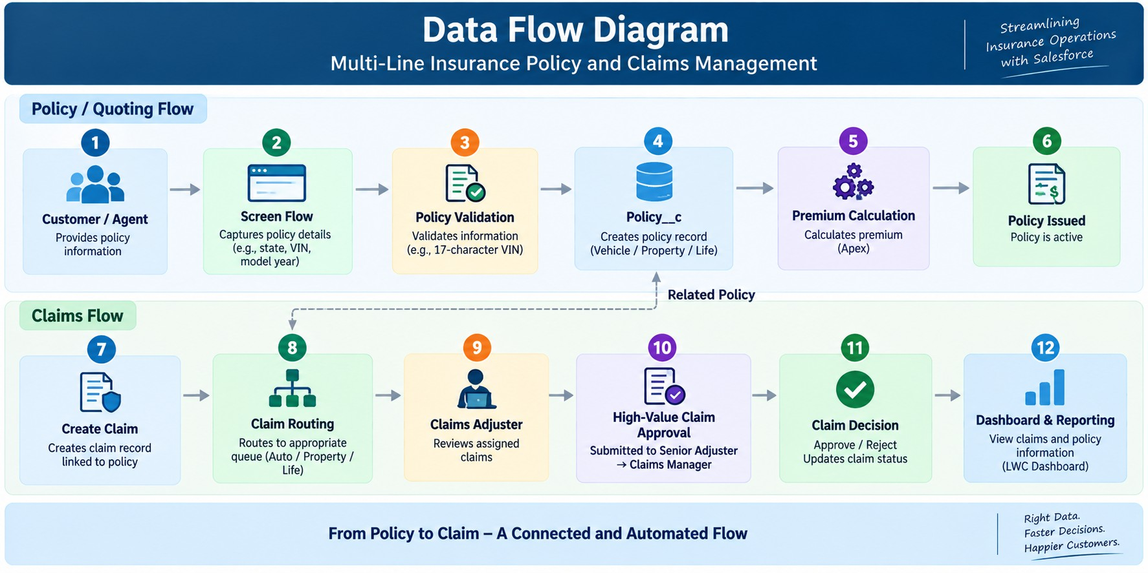

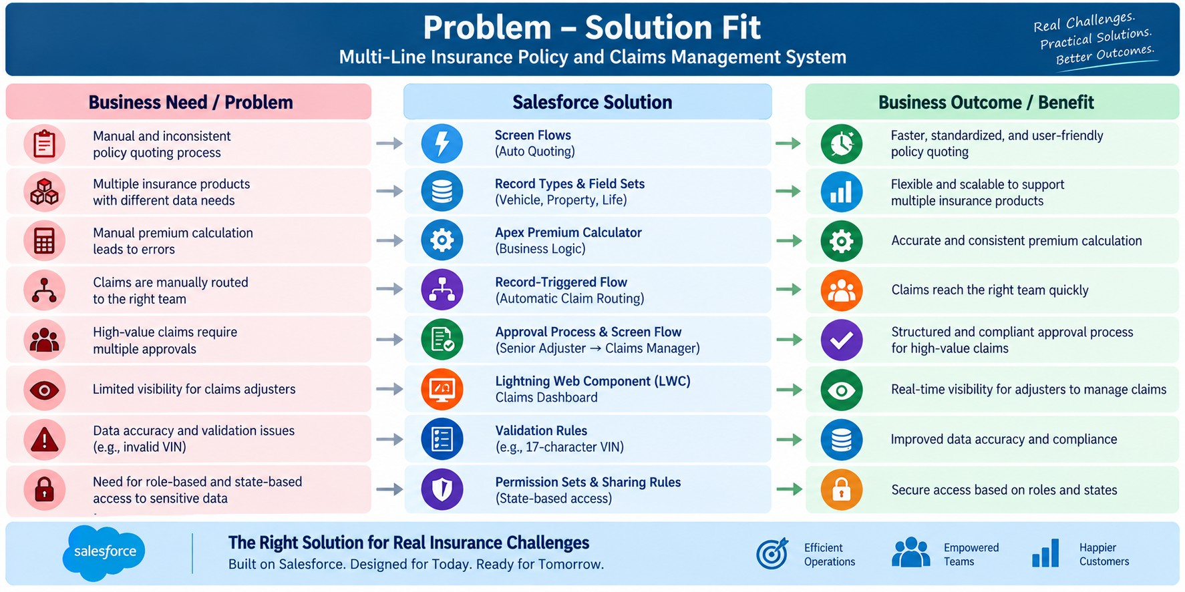

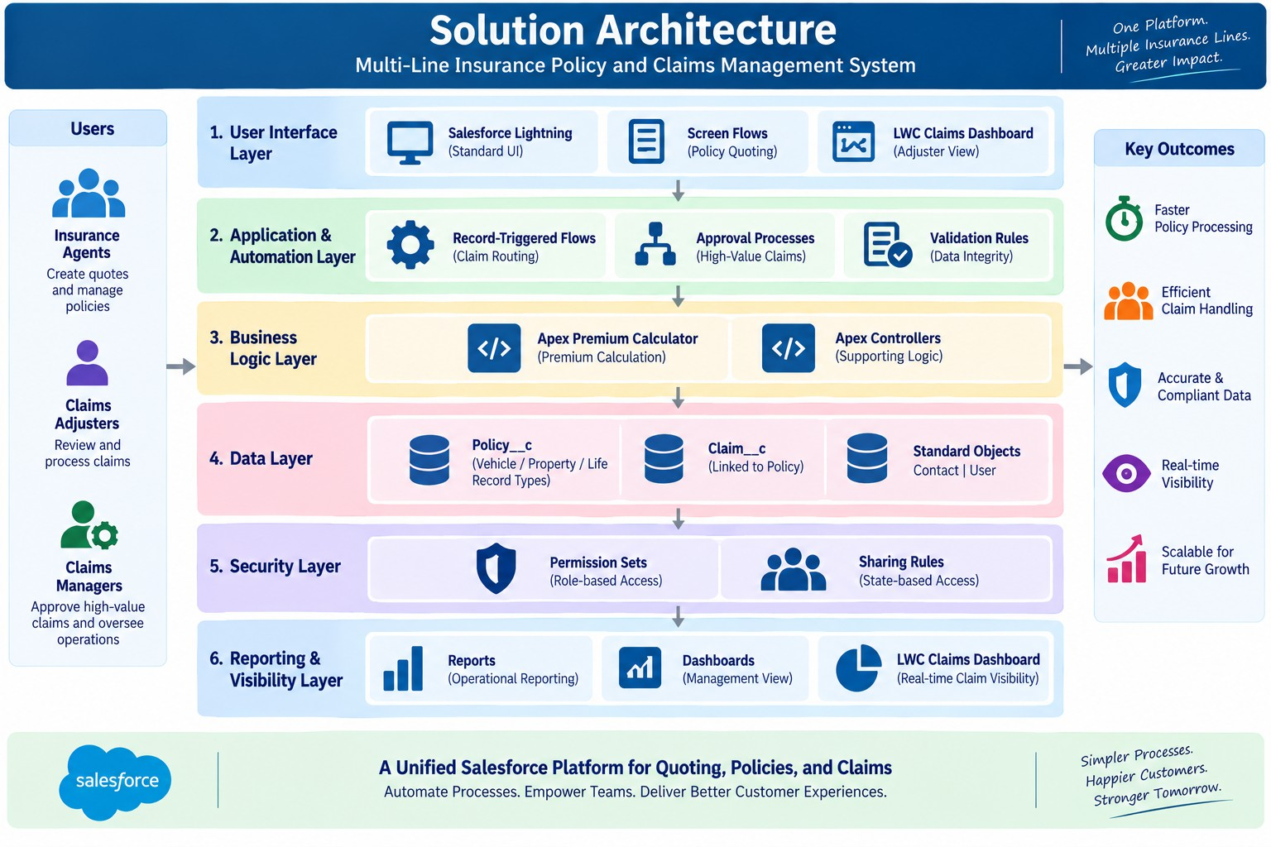

PROJECT PLANNING &SCHEDULING

Agile Planning
    - Break the project into small functional increments.
    - Implement customer and policy data before claim automation.
    - Validate Flow behavior before connecting Agentforce.
    - Test each insurance line and claim path independently.
    - Use Git to maintain project source and metadata.

Product Backlog

ID | Epic | User Story / Task | Points
US-01 | Environment | Configure Salesforce project and development environment | 3
US-02 | Customer | Create Customer object/records | 5
US-03 | Policy | Create Insurance Policy object | 5
US-04 | Policy | Add multi-line policy fields and relationships | 5
US-05 | Claim | Create Insurance Claim object | 5
US-06 | Automation | Build policy and claim validation Flow | 8
US-07 | Assignment | Implement claim handling assignment | 5
US-08 | Agentforce | Create Policy & Claims Assistance action | 8
US-09 | Testing | Validate policy and claim scenarios | 5
US-10 | Version Control | Retrieve and push Salesforce metadata | 3

Sprint Roadmap

Sprint | Main Deliverable | Validation Point
Sprint 1 | Salesforce environment | Org/project initialized
Sprint 2 | Customer and Policy objects | Records can be stored
Sprint 3 | Claim object and Flow | Validation behavior verified
Sprint 4 | Agentforce integration | Conversation invokes Flow
Sprint 5 | Testing and refinement | Multiple insurance scenarios validated

Project Tracking
Progresscanbetrackedusingthebacklog,sprintdeliverables,Flowvalidationresultsandtestcases.Each completed feature should be validated before moving to the next sprint.

Multi-Line Insurance Policy and Claims Management System | Page 8

PROJECT DEVELOPMENT PHASE

Salesforce Environment
The development environment uses Salesforce and a Salesforce DX project. The project source can be maintained locallyandsynchronizedwithGitHubsometadatasuchasobjects,fields,flowsandAgentforceconfigurationcanbe versioned.

Component | Project Value
Salesforce Org | Runtime configuration and testing
Salesforce DX Project | Local source representation
Salesforce CLI | Retrieve, inspect and deploy metadata
Git | Version control
GitHub | Remote project repository

Custom Objects

Object | API Name | Purpose
Customer | Customerc | Stores customer information
Insurance Policy | Insurance_Policyc | Stores policy and coverage information
Insurance Claim | Insurance_Claimc | Stores claim information

Fields and Relationships

Field | Type | Purpose
Policy Number | Auto Number/Text | Unique policy identifier
Customer | Lookup(Account/Customer) | Links policy to customer
Insurance Line | Picklist | Health, Motor, Life, Property
Coverage Amount | Currency | Stores coverage value
Premium Amount | Currency | Stores premium amount
Policy Status | Picklist | Active, Expired, Cancelled, Pending
Start Date | Date | Policy start date
End Date | Date | Policy expiry date
Claim Number | Auto Number | Unique claim identifier
Claim Amount | Currency | Requested claim amount
Claim Status | Picklist | Submitted, Under Review, Approved, Rejected, Settled
Claim Date | Date | Date of claim
Assigned To | Lookup(User) | Claims staff reference

Flow Design
FlowType:Auto-LaunchedFlow.InputscanincludeCustomerName,PolicyNumberandClaimNumber.Outputs include Customer Id, Policy Id, Claim Id, Policy Status, Claim Status, Assigned Team and Action Message.

Flow Implementation

Stage | Implementation
1. Customer Lookup | Find the requested customer record.

Multi-Line Insurance Policy and Claims Management System | Page 9

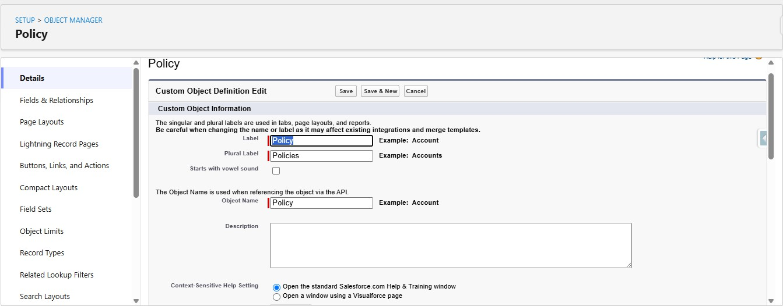

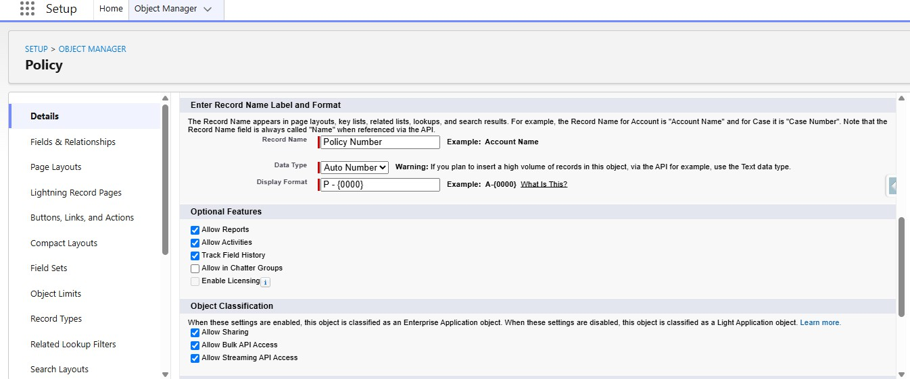

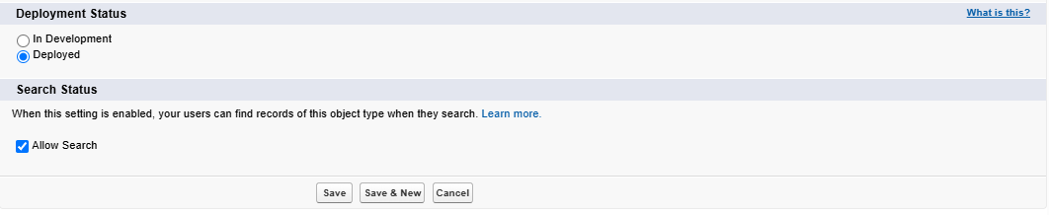

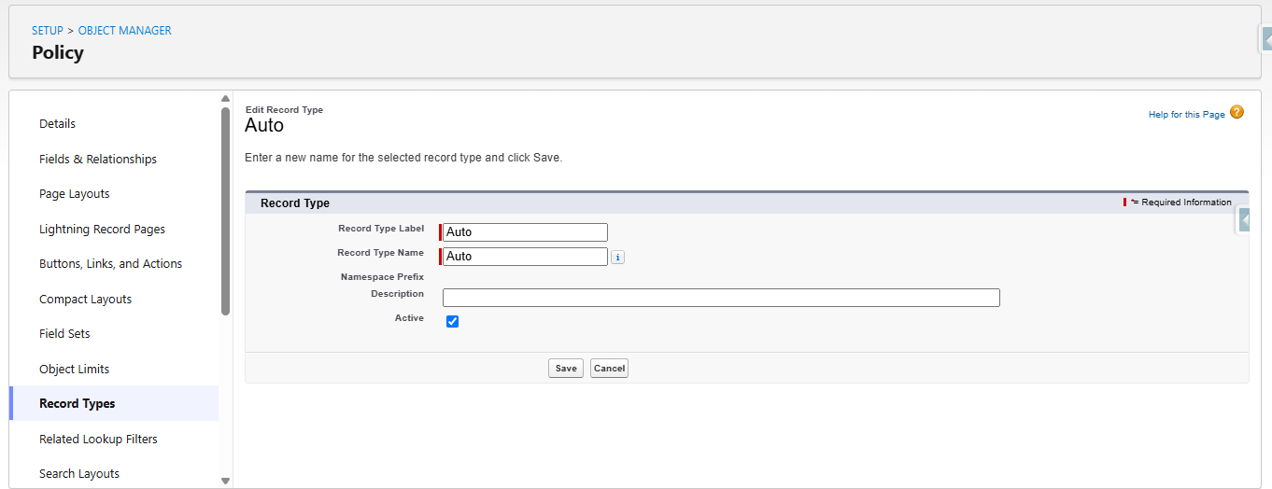

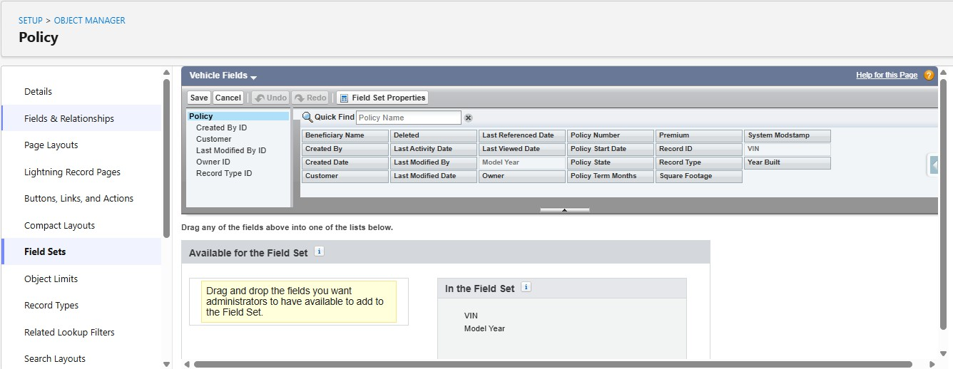

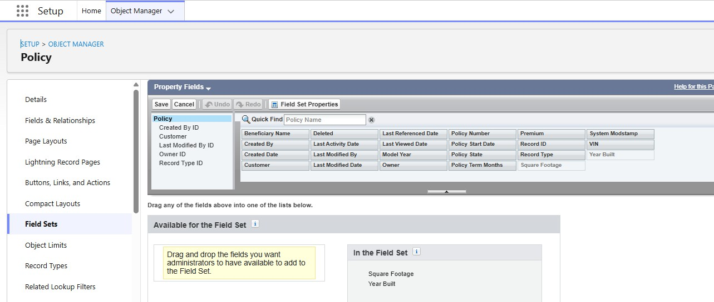

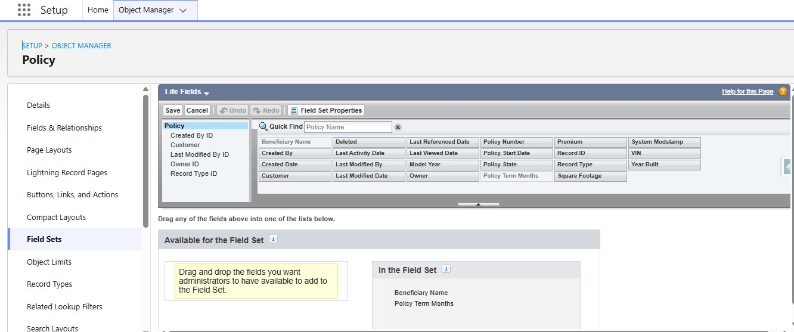

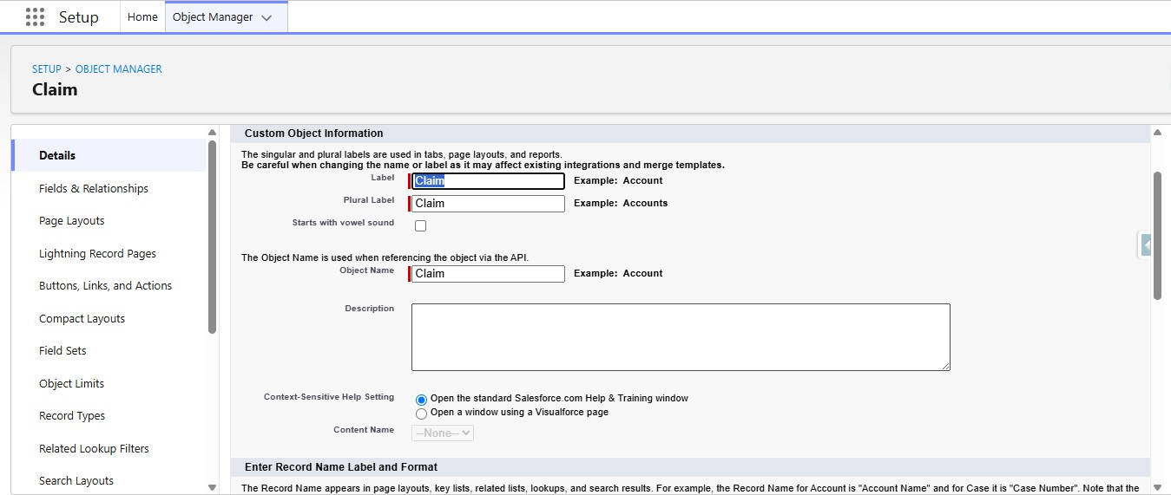

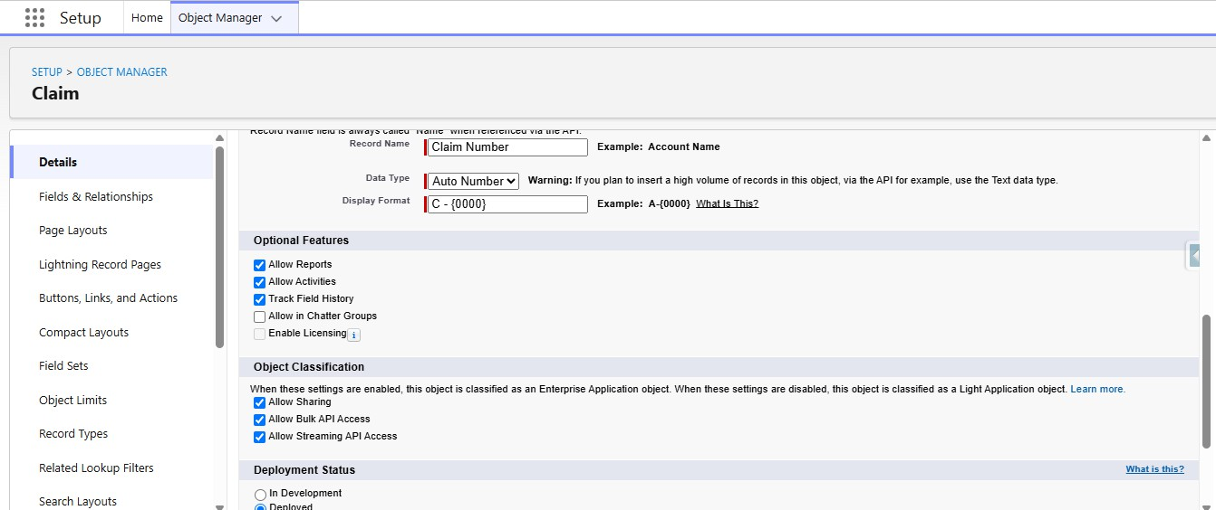

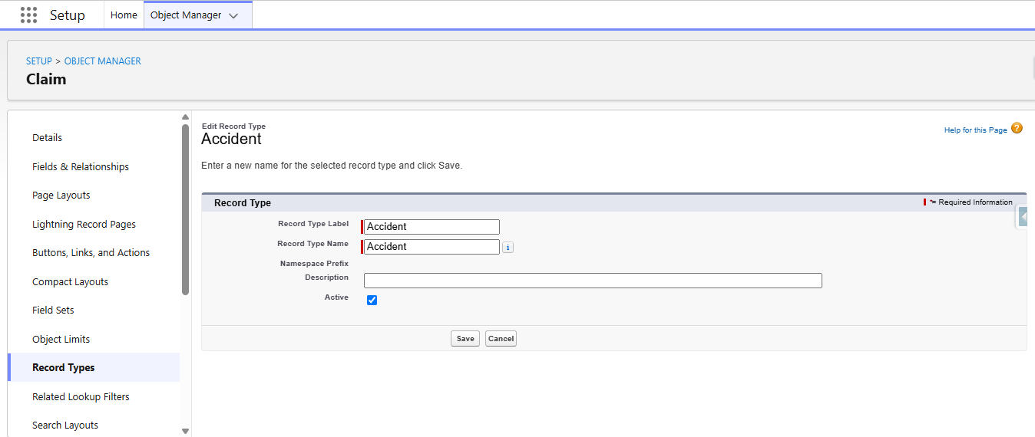

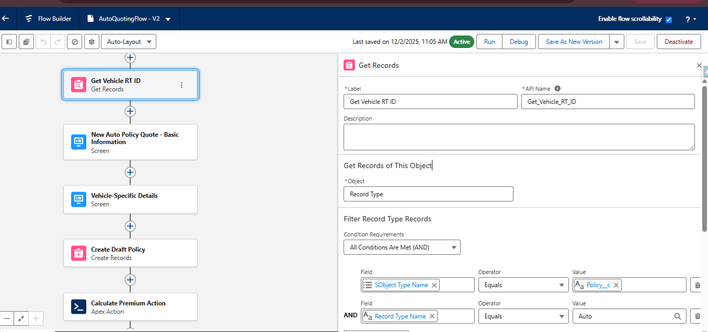

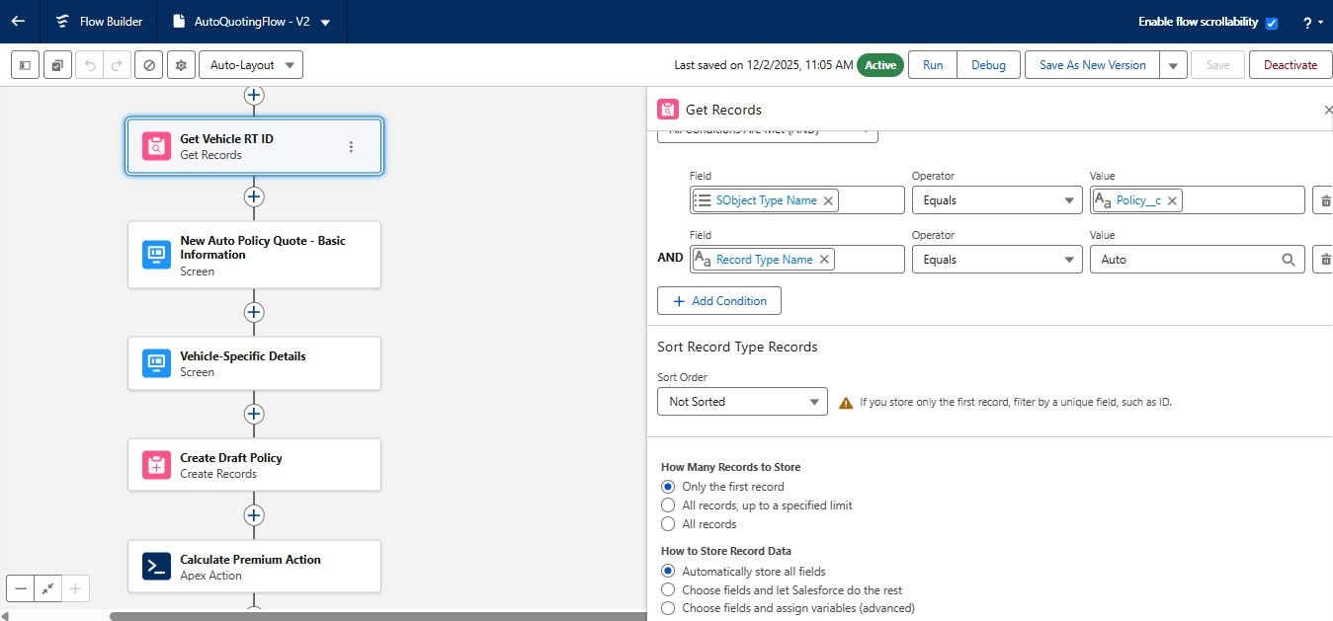

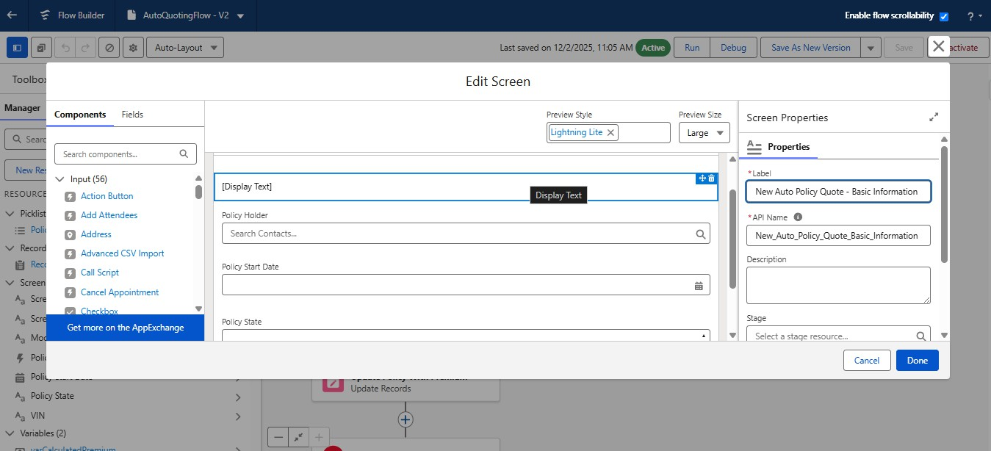

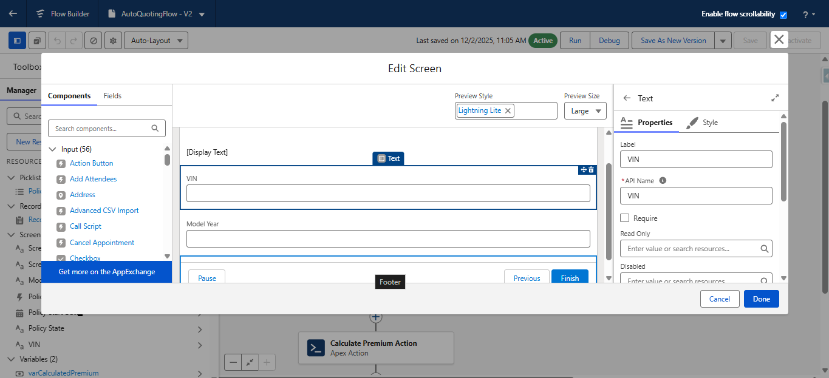

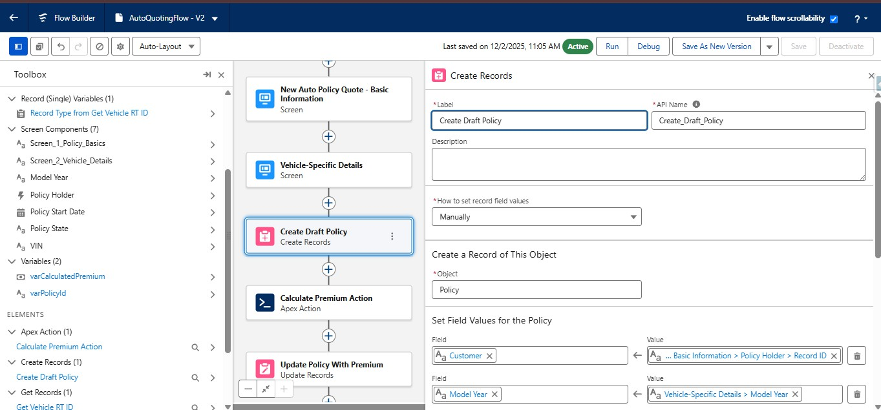

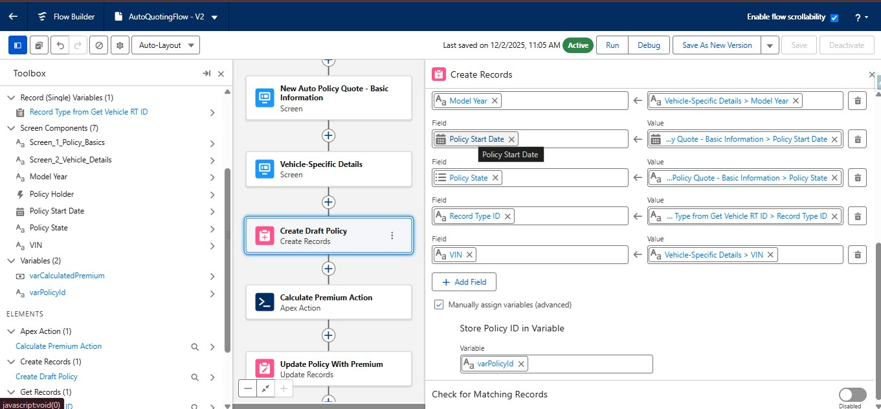

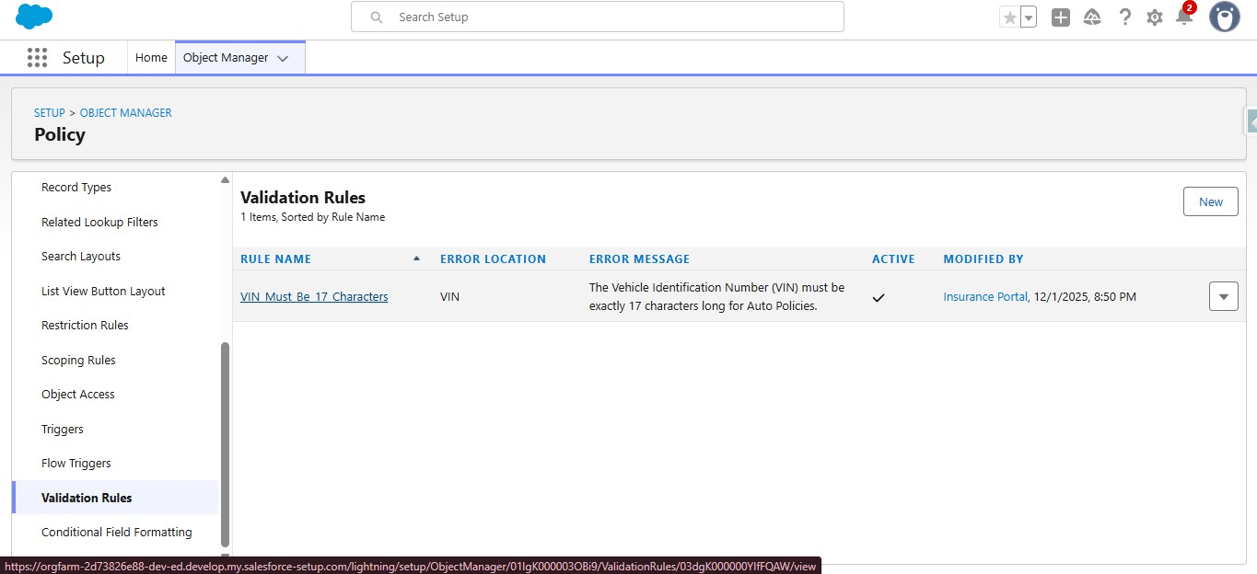

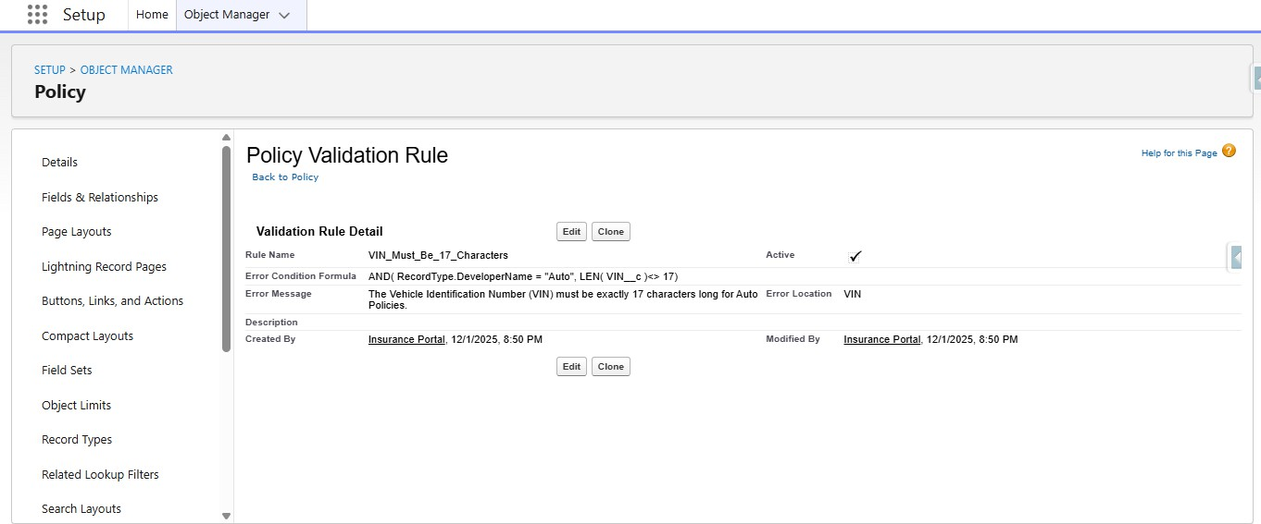

Stage | Implementation
2. Policy Lookup | Find the relevant policy linked to the customer.
3. Policy Status Check | Check whether the policy is active.
4. Claim Lookup/Create | Retrieve an existing claim or create a new claim record.
5. Coverage Check | Check insurance line and configured coverage information.
6. Claim Validation | Check required claim information and basic eligibility.
7. Status Assignment | Set Submitted, Under Review, Approved or Rejected according to configured rules.
8. Assignment | Set the appropriate claims handling level.
9. Follow-up Task | Create a task for selected cases requiring manual attention.
10. Final Message | Return the corresponding action message.

Multi-Line Insurance Policy and Claims Management System | Page 10

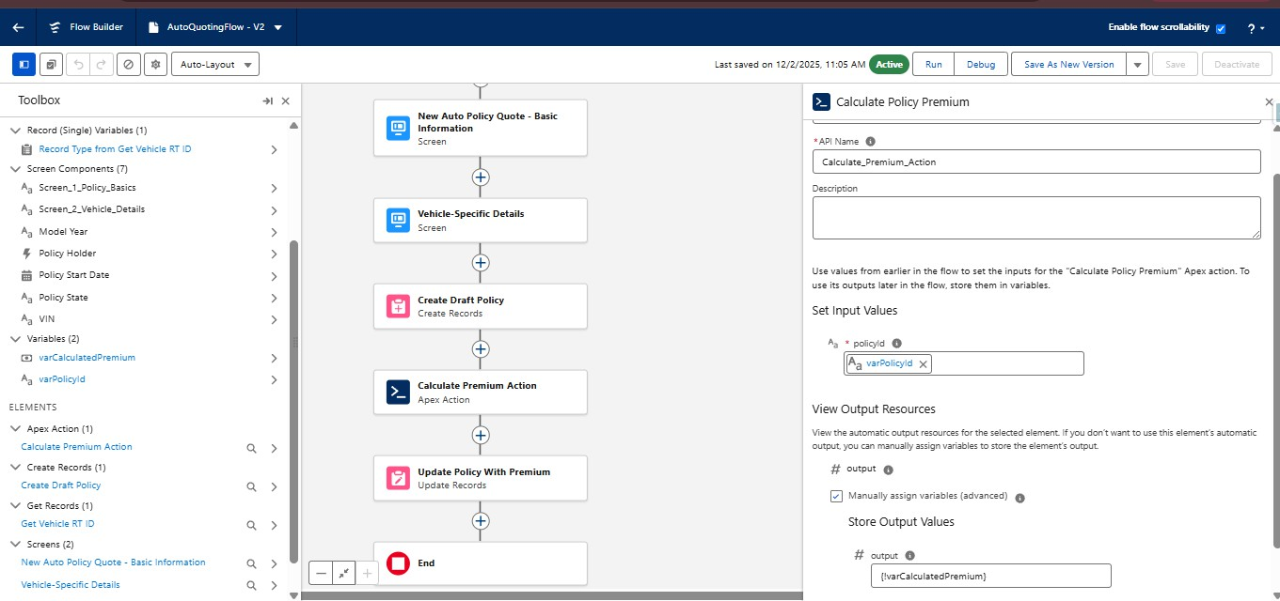

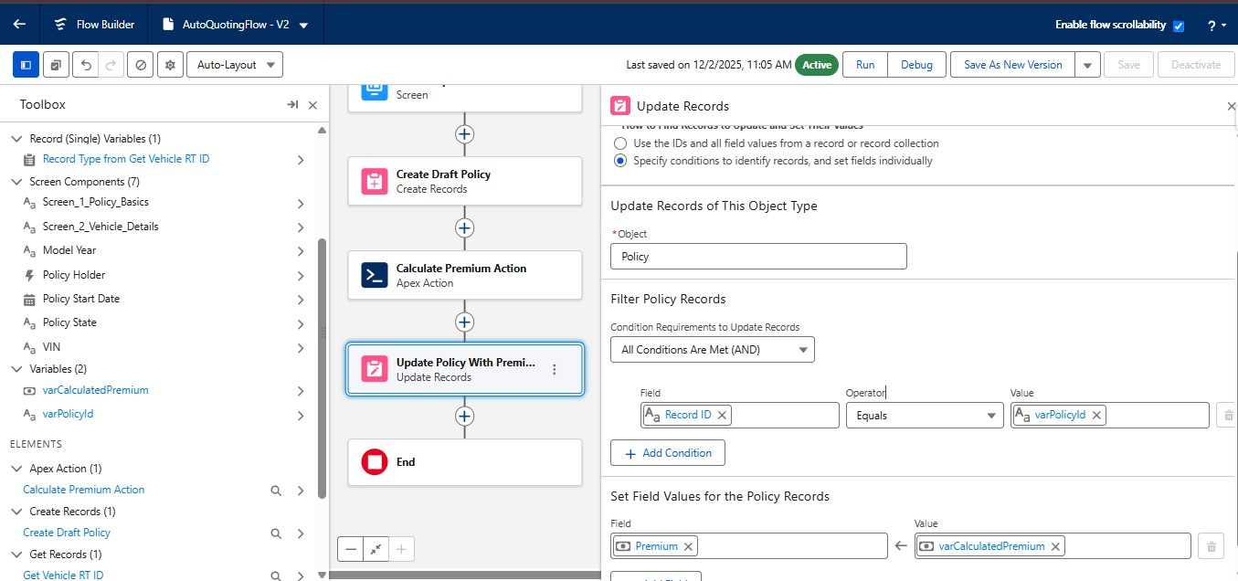

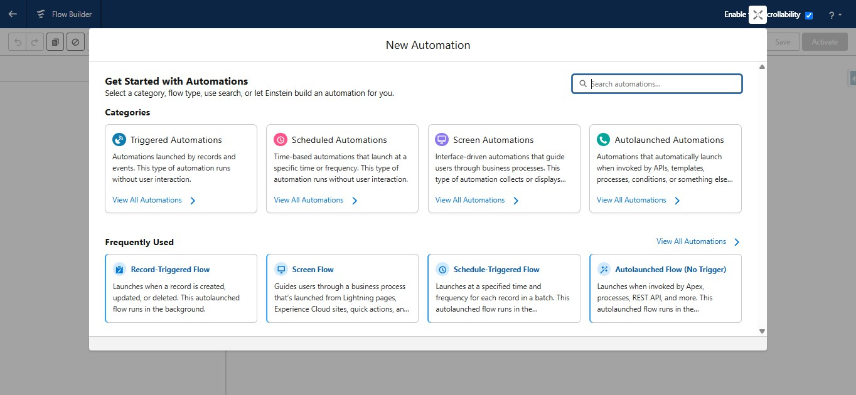

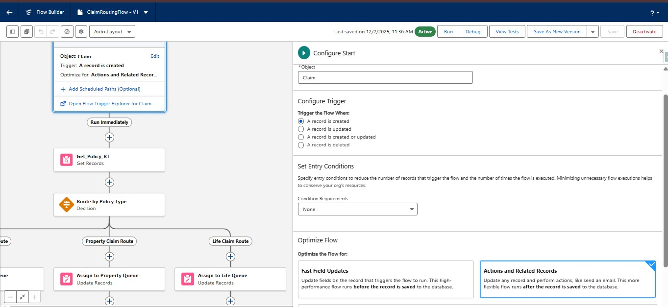

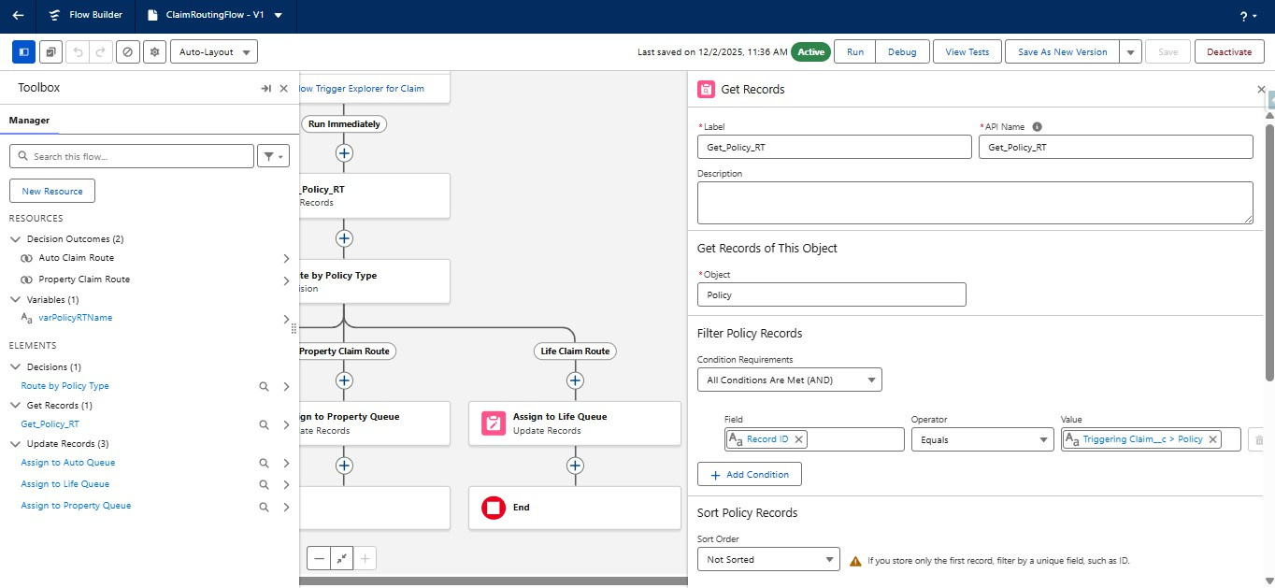

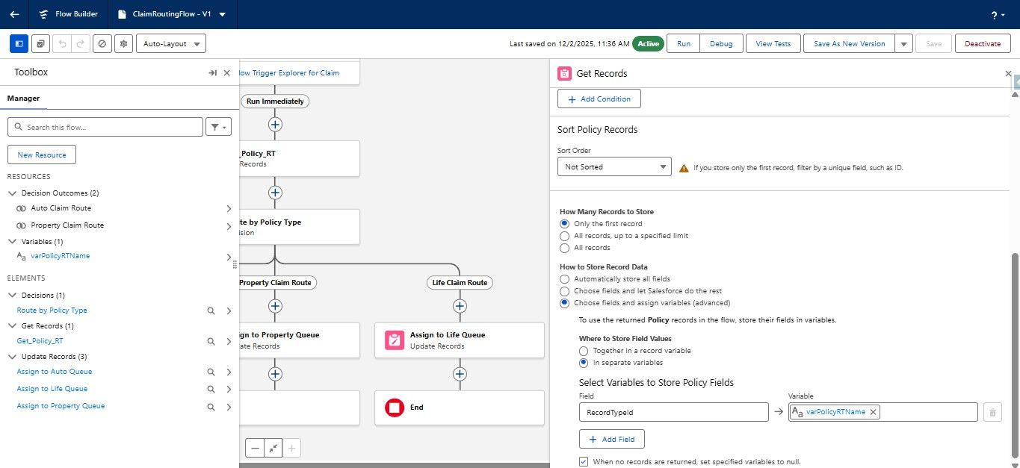

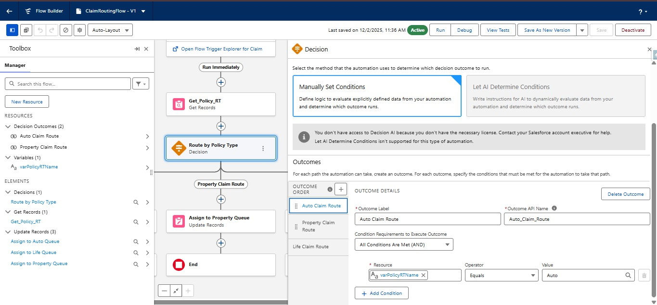

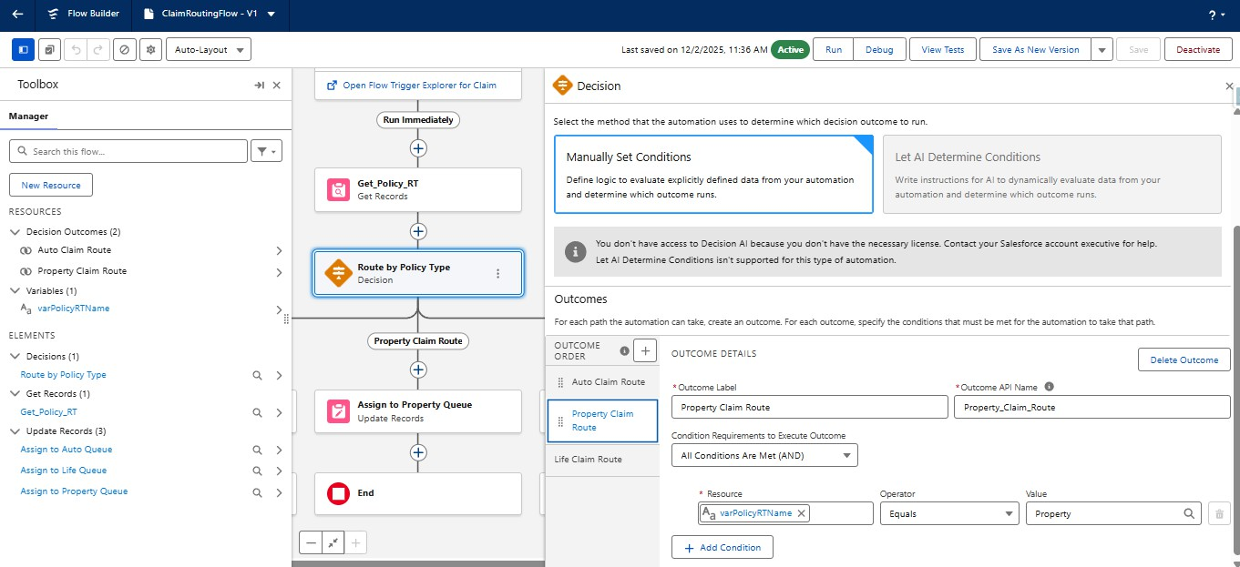

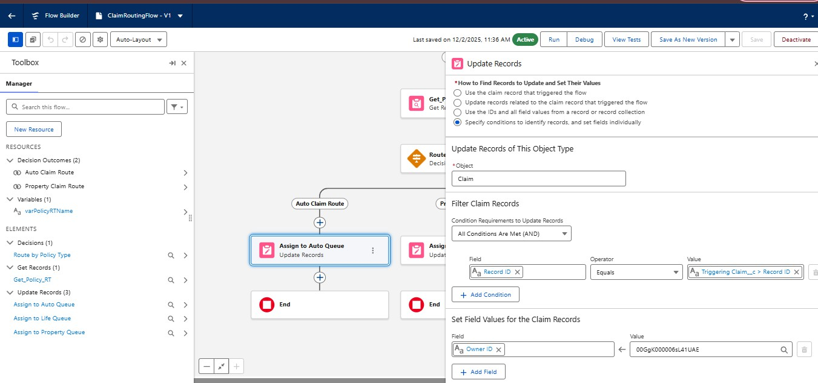

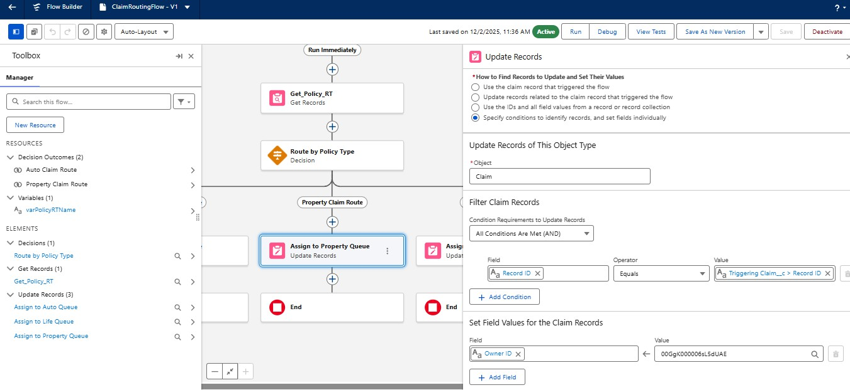

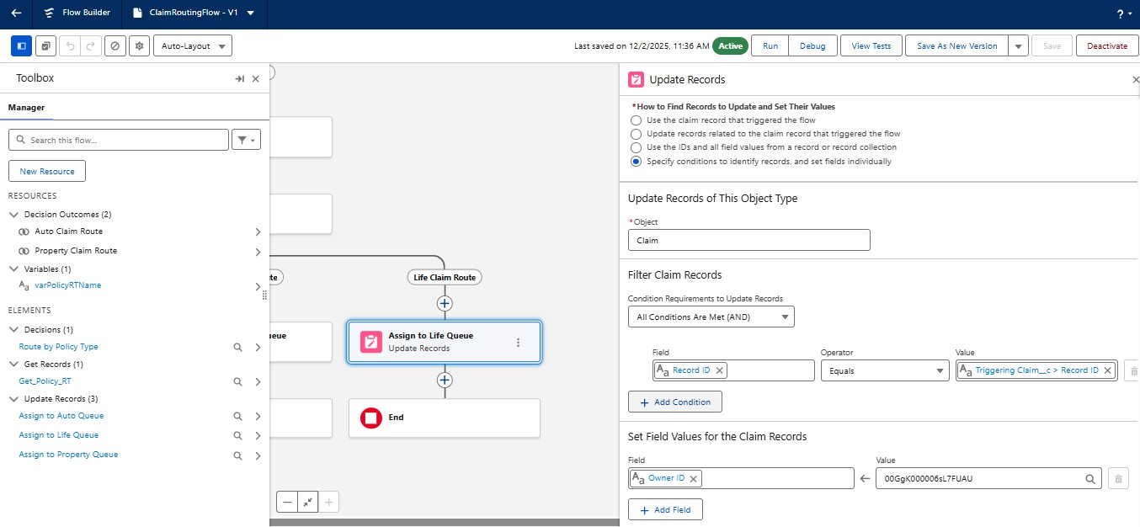

Agentforce Configuration
TheAgentforceconfigurationusesasubagentsuchas“InsurancePolicyandClaimsAssistance”.Itsscopeislimited to customer policy lookup, policy information, claim registration/status assistance and triggering the approved backend Flow action. It should not perform unrelated account or financial updates.

Agentforce Action

Property | Configuration
Action | Insurance Policy & Claims Flow action
Inputs | Customer Name, Policy Number / Claim Number as required
Loading Text | Checking policy and claim details...
Backend | Auto-Launched Insurance Policy and Claims Flow
Purpose | Retrieve records, validate policy/claim conditions and return handling outputs

Input and Output Contract

Direction | Variable | Meaning
Input | varCustomerName | Customer name
Input | varPolicyNumber | Policy identifier when supplied
Input | varClaimNumber | Claim identifier when supplied
Output | varCustomerId | Customer identifier
Output | varPolicyId | Policy identifier
Output | varClaimId | Claim identifier
Output | varPolicyStatus | Current policy status
Output | varClaimStatus | Current claim status
Output | varAssignedTeam | Claims handling level
Output | varActionMessage | Final handling message

Multi-Line Insurance Policy and Claims Management System | Page 11

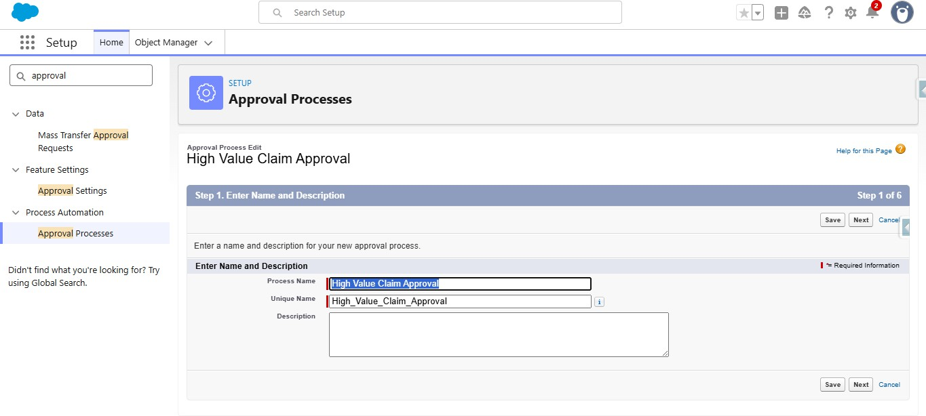

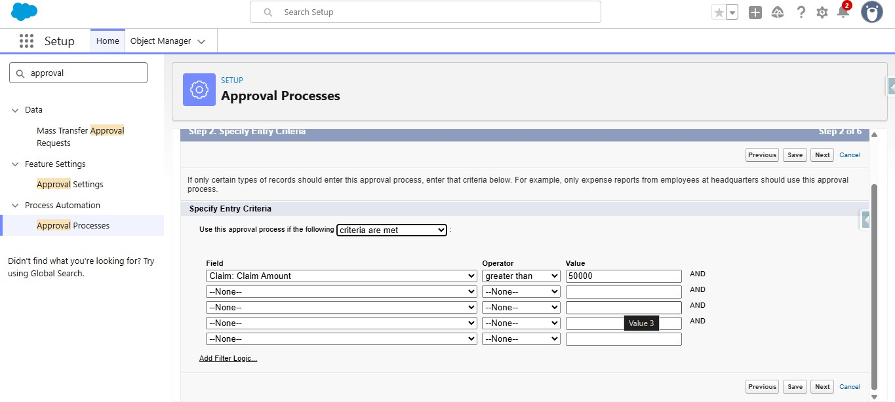

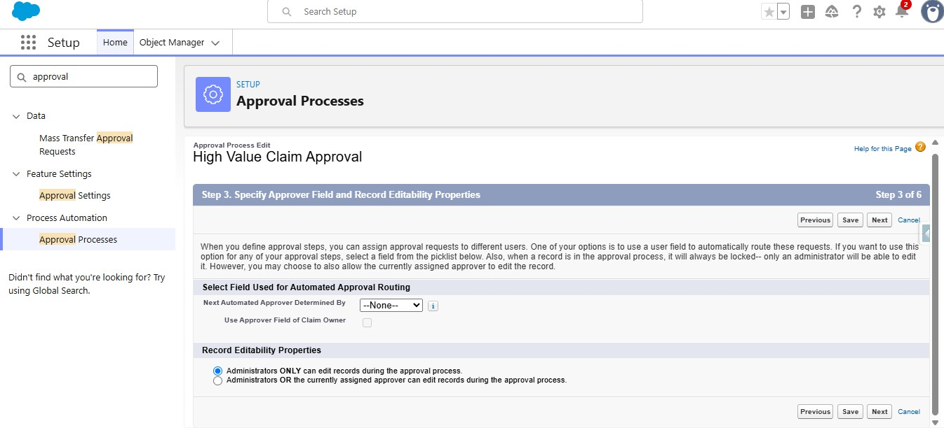

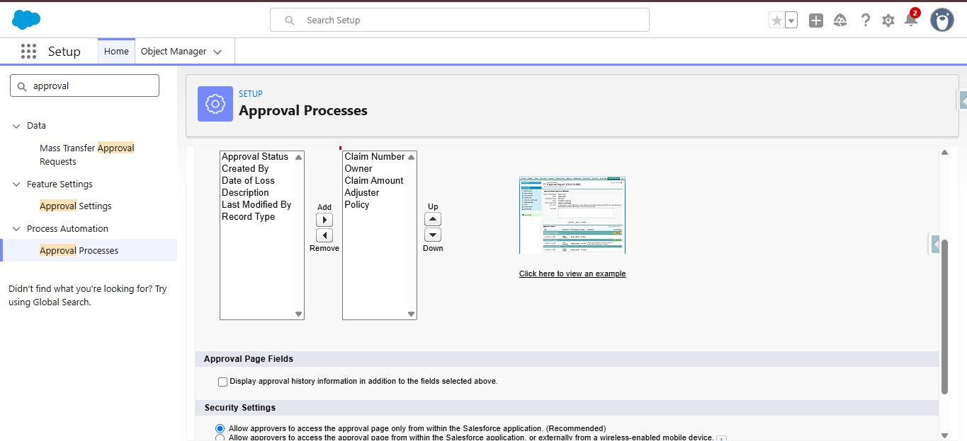

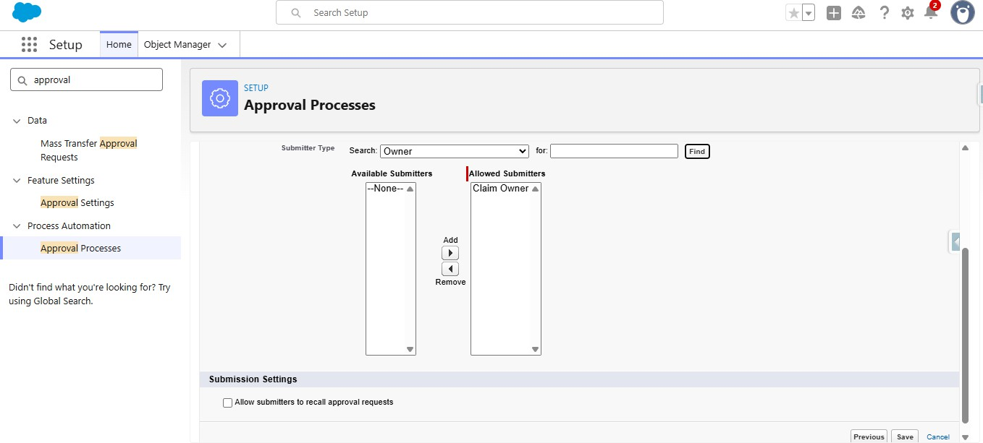

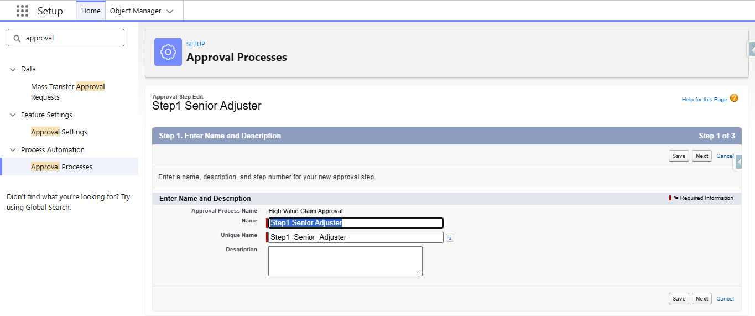

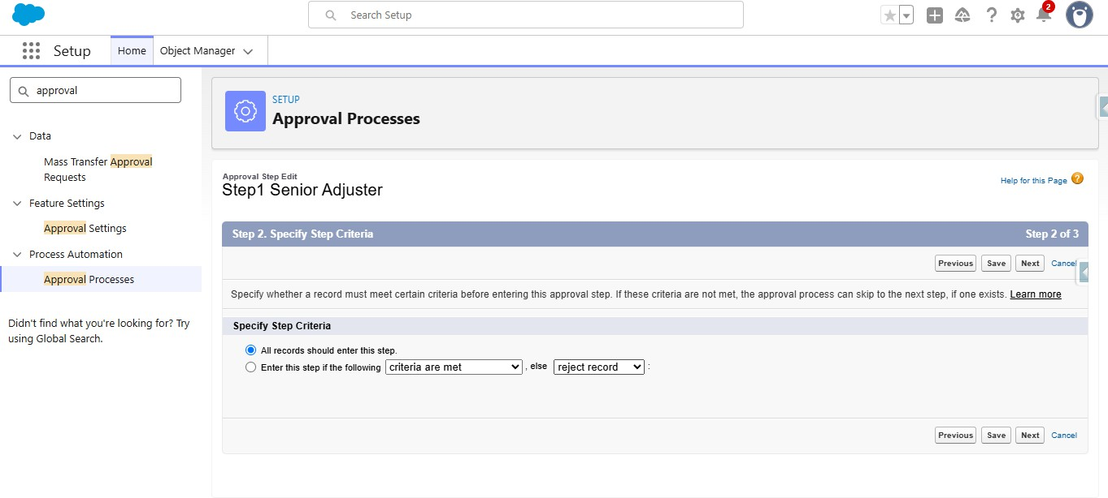

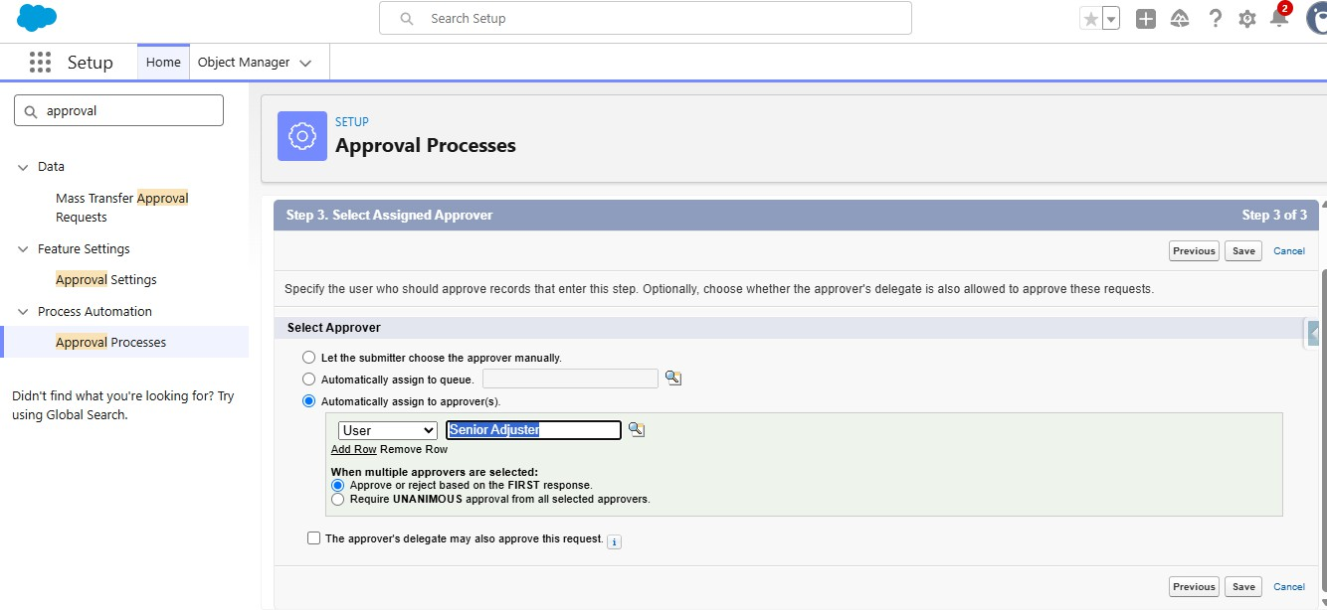

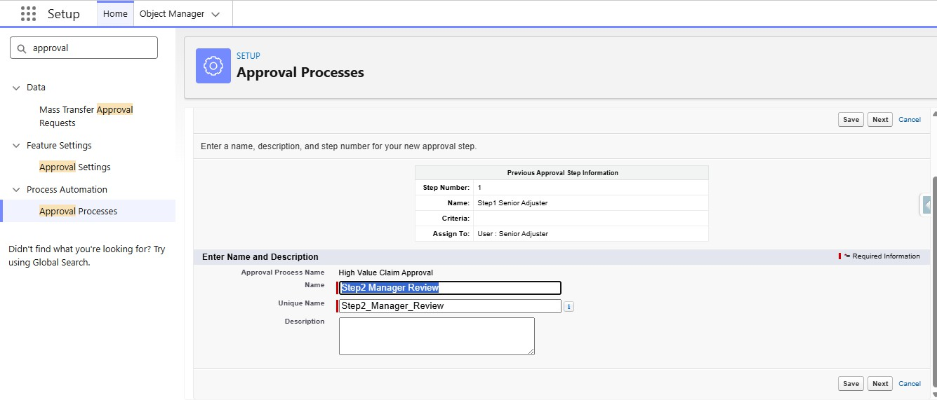

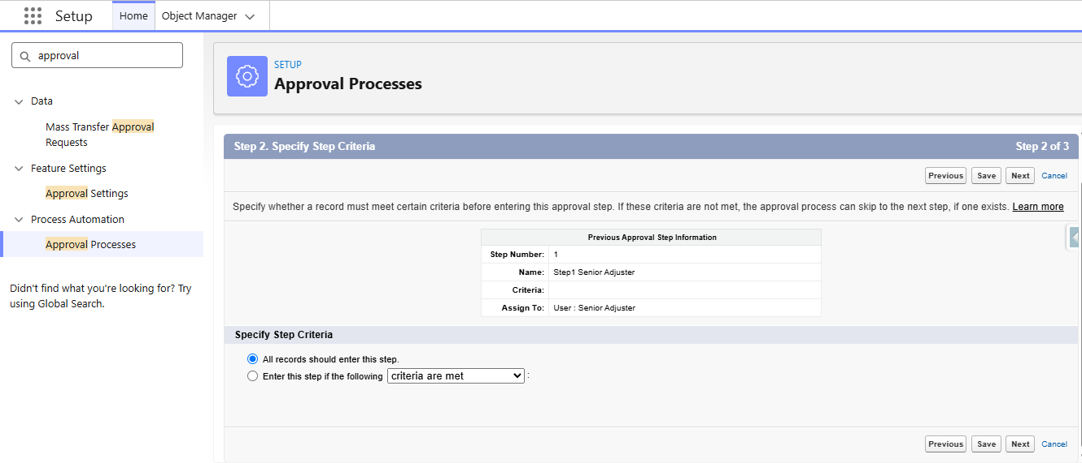

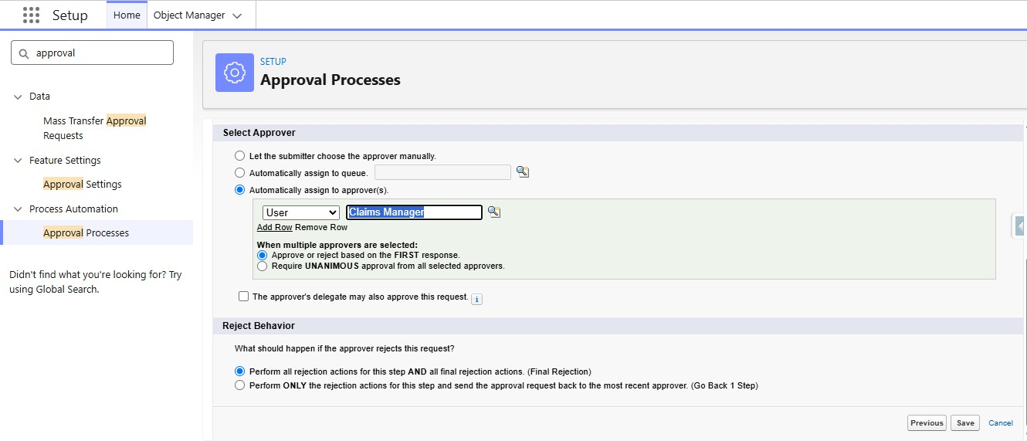

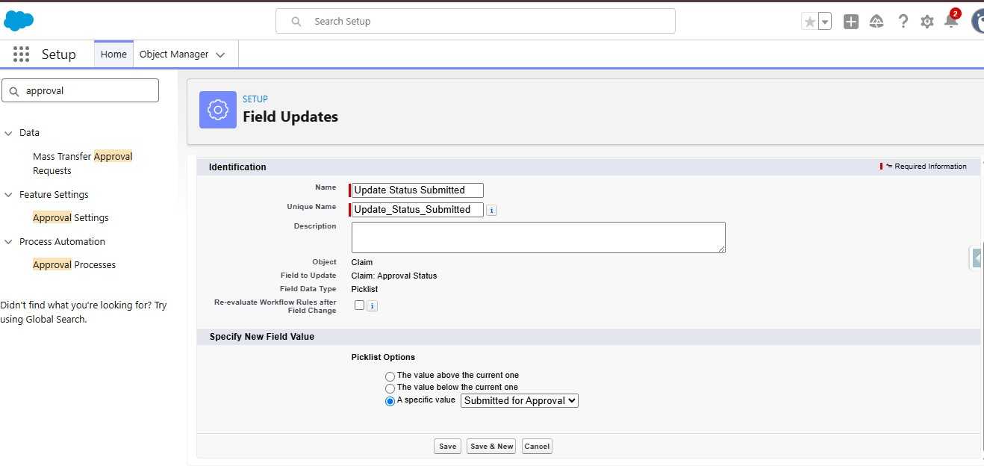

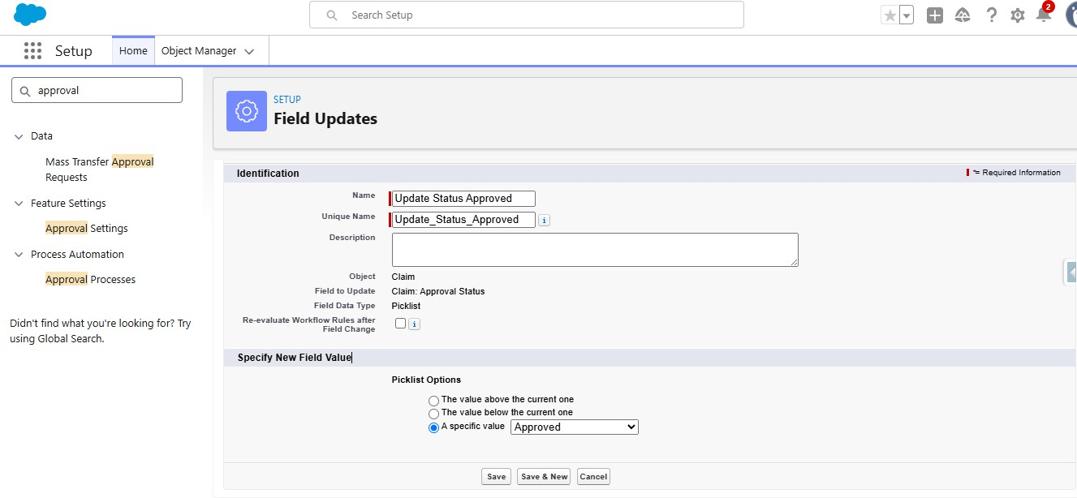

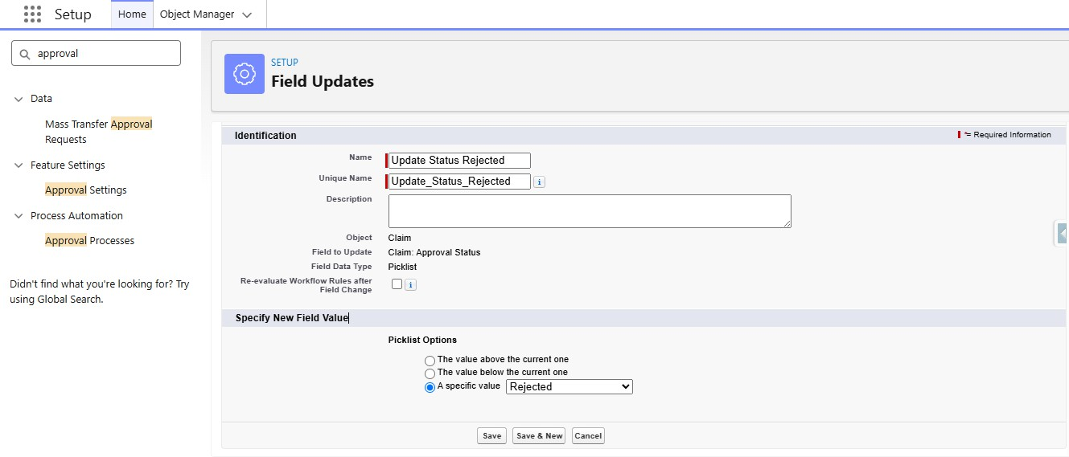

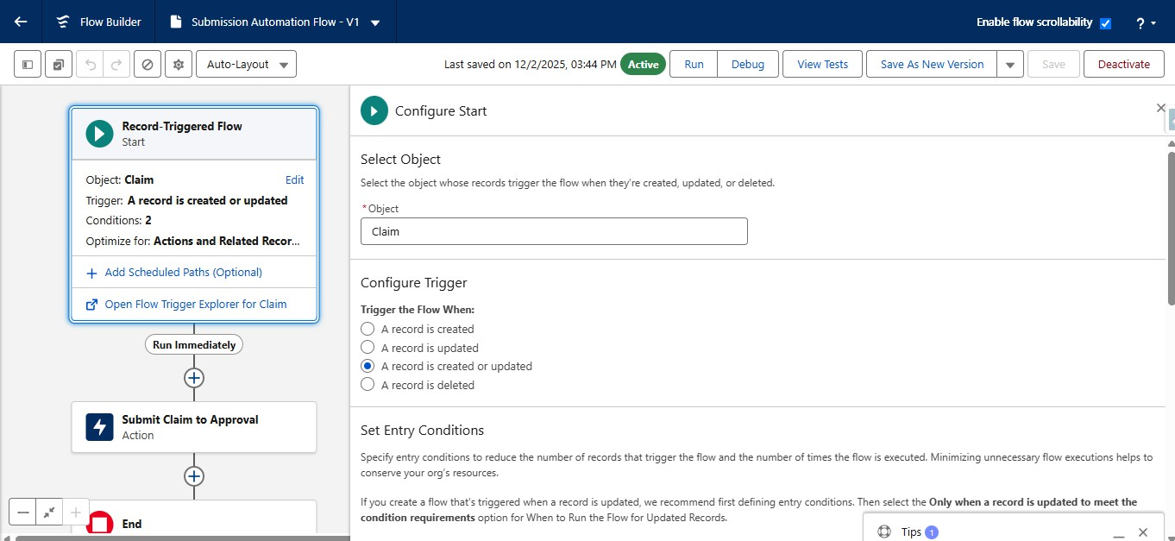

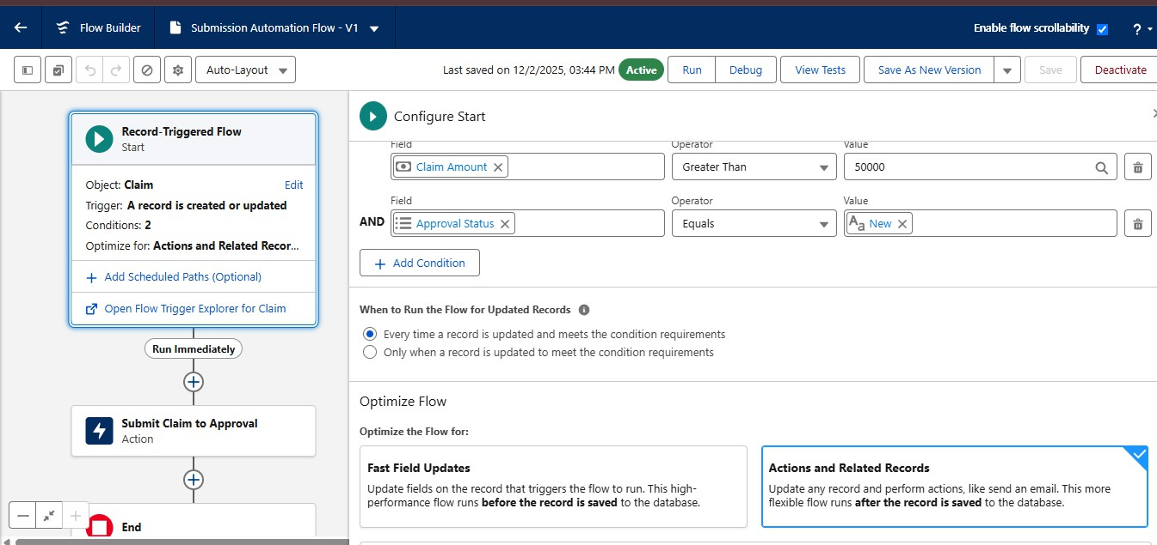

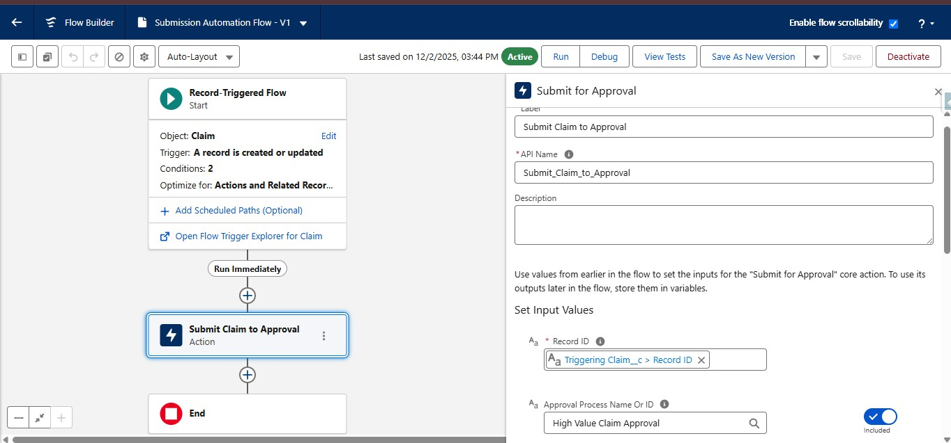

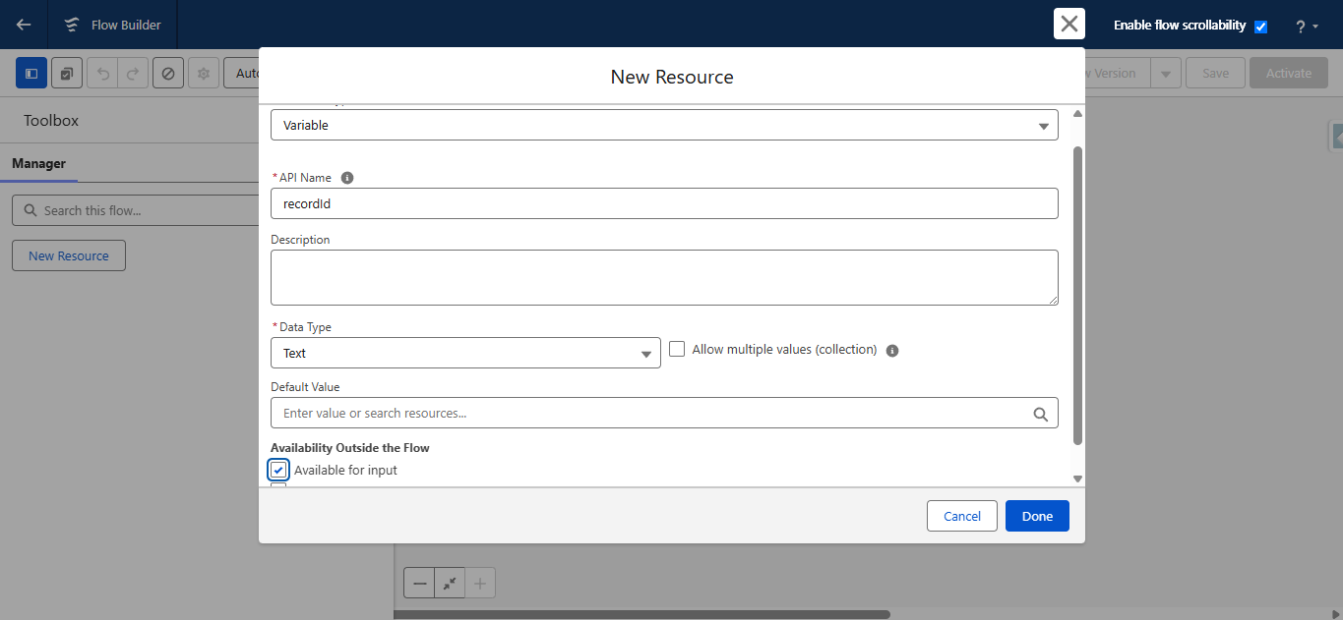

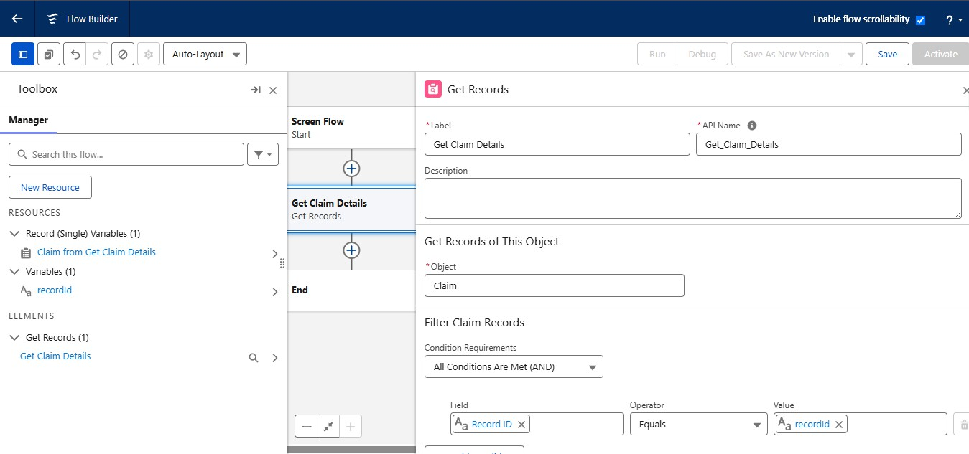

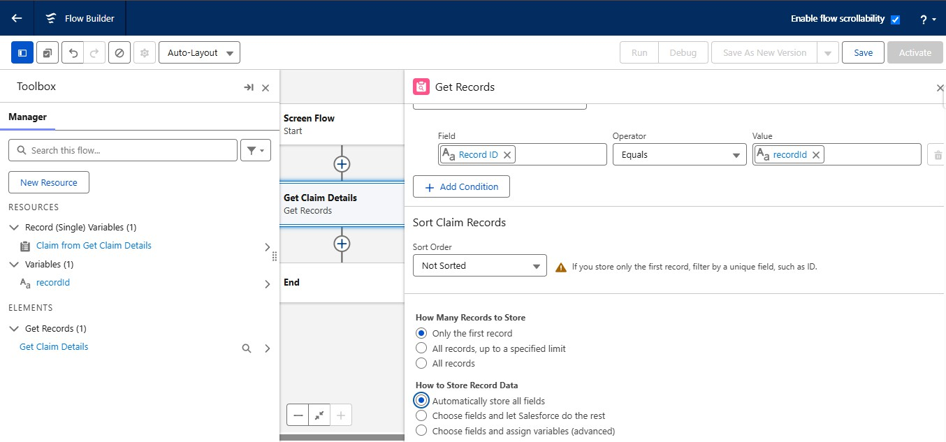

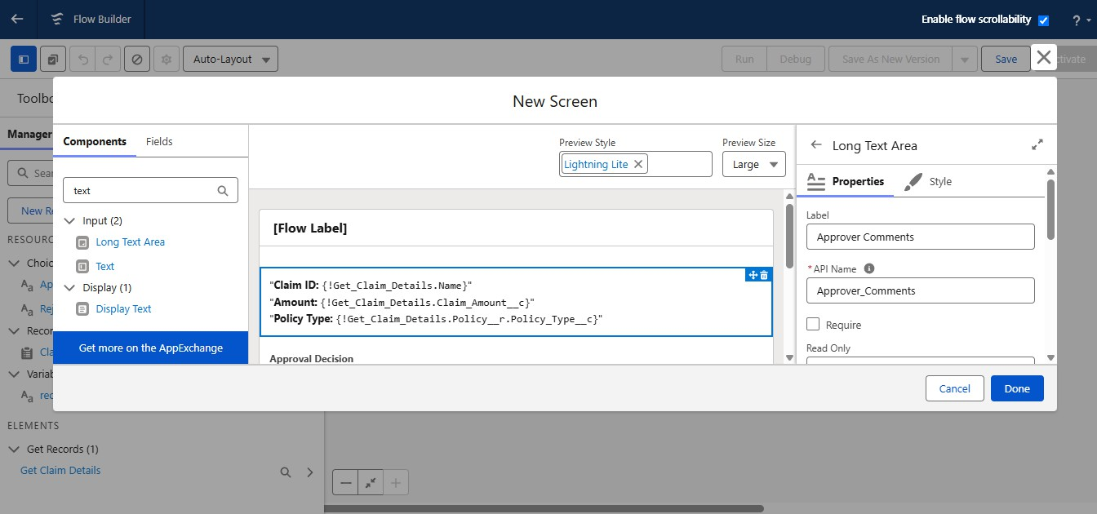

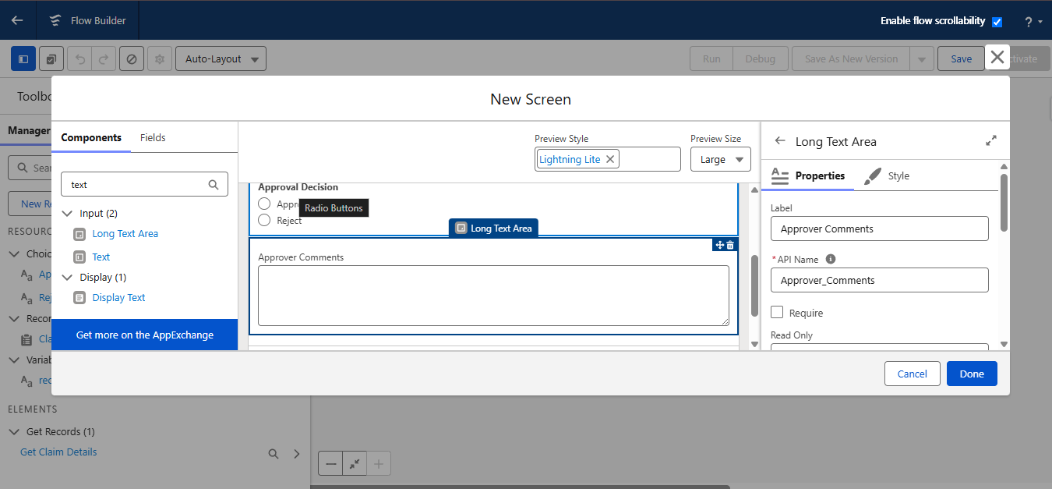

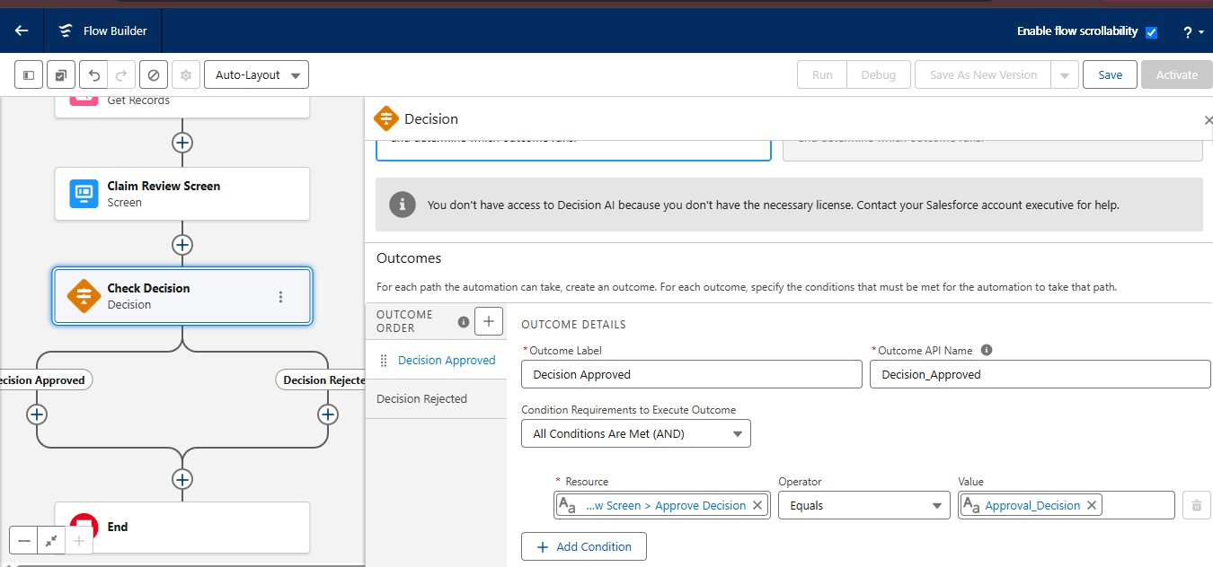

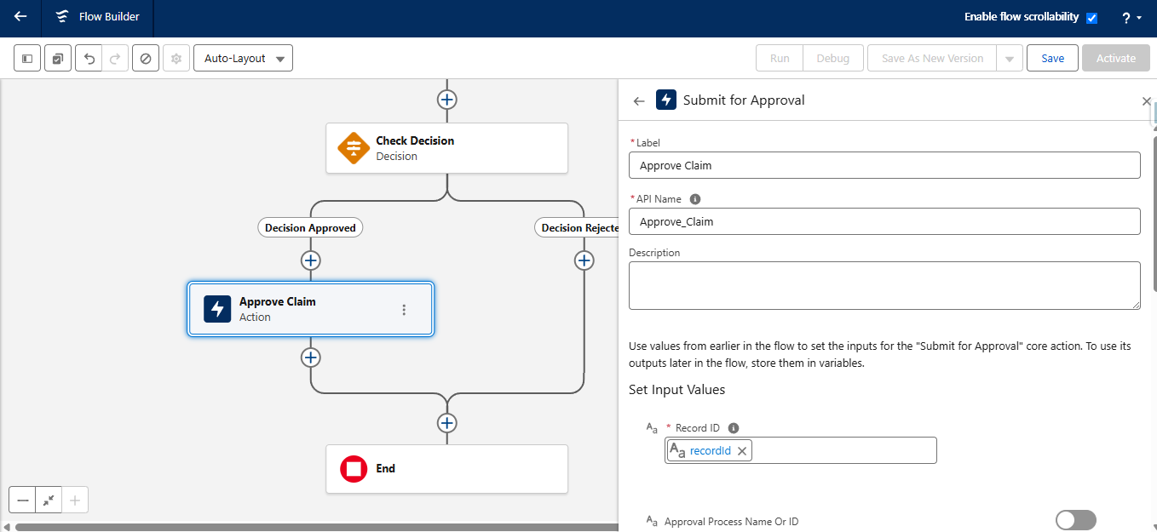

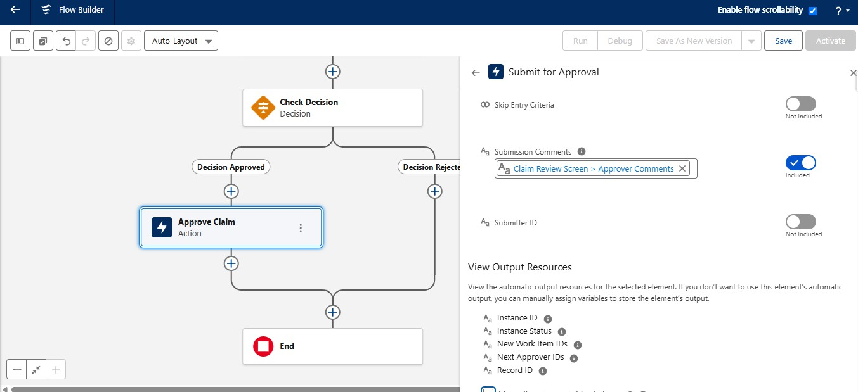

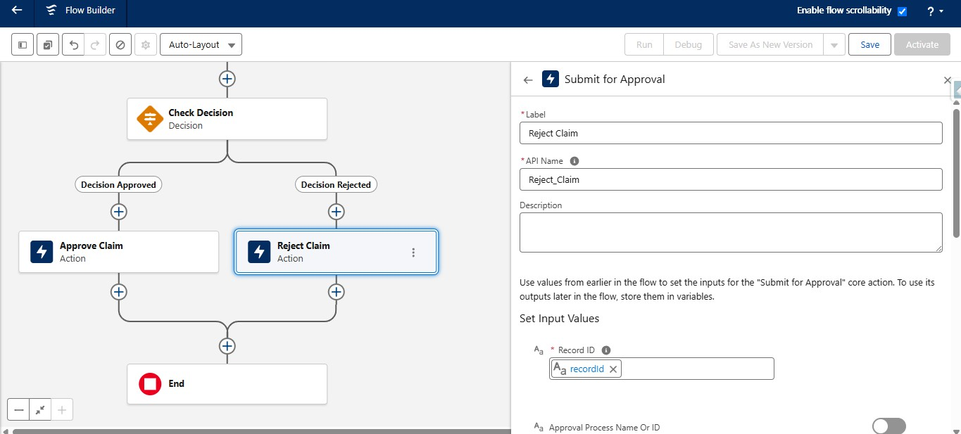

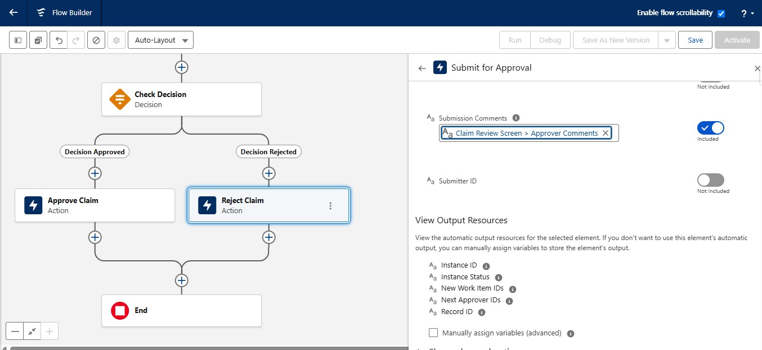

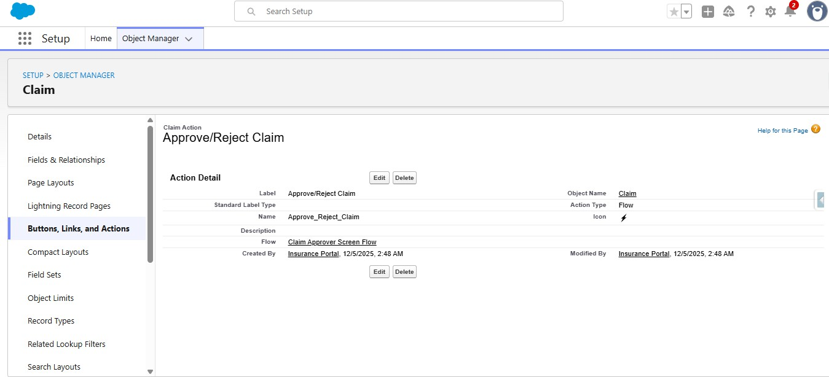

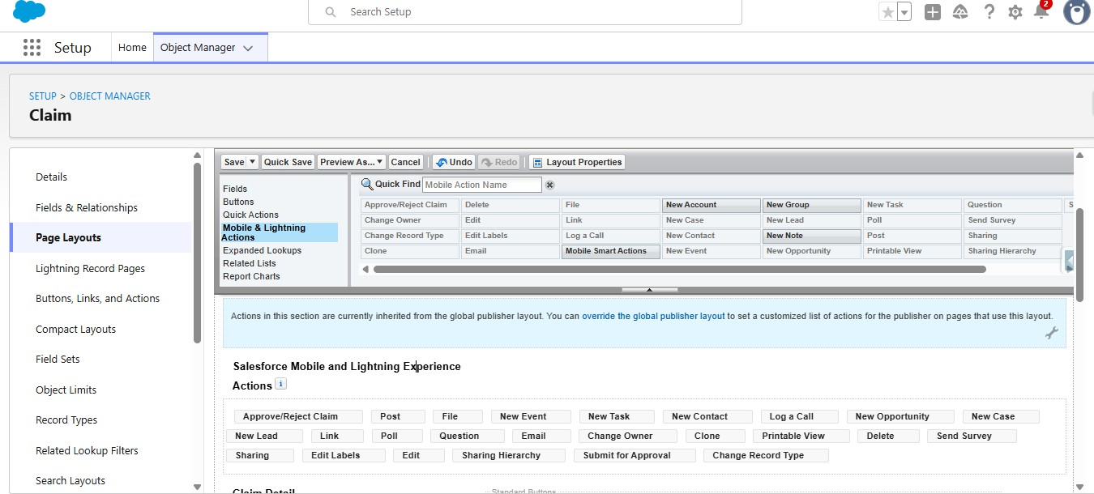

FUNCTIONAL & PERFORMANCE TESTING

Test Strategy
Testingcoversthecompleteautomationchain:customeridentification,policyretrieval,policy-statuschecking,claim registration or retrieval, coverage validation, claim status decision, assignment, follow-up task creation and Agentforce response.

Test Cases
Test ID | Scenario | Input Condition | Expected Result
TC-01 | Active policy | Policy status = Active | Policy is eligible for basic claim process
TC-02 | Expired policy | Policy status = Expired | Claim is not processed as an active-pol
TC-03 | Cancelled policy | Policy status = Cancelled | Claim is flagged for appropriate handlin
TC-04 | Missing claim data | Required claim information missing | Claim returned for completion
TC-05 | Health claim | Active Health policy | Claim routed to configured handling pat
TC-06 | Motor claim | Active Motor policy | Claim routed to configured handling pat
TC-07 | Life claim | Active Life policy | Claim routed to configured handling pat
TC-08 | Property claim | Active Property policy | Claim routed to configured handling pat
TC-09 | Claim status | Valid claim number supplied | Current claim status returned
TC-10 | Agentforce | Customer/policy information supplied | Agentforce returns analysis output

ing
icyclaim g

hhhh

Claim Validation
Aclaimvalidationscenarioshouldverifythepolicyrelationship,policystatus,insuranceline,claimdateandrequired claim information. Cases requiring manual review should be routed to the configured claims team rather than being silently approved.

Agentforce Validation
AsuccessfulAgentforcetestshouldreturntherelevantcustomer/policy/claimidentifier,policystatus,claimstatus, assigned handling level and action message after the Flow action executes.

Test Summary
    - Customer and policy retrieval are part of the automated process.
    - Active and inactive policy paths follow configured rules.
    - Claims with missing information are flagged for completion.
    - Different insurance lines can be represented through the policy data model.
    - Agentforce provides the conversational entry point to the automation.
    - The proposed decision logic is rule-based rather than a trained predictive ML classifier.

Multi-Line Insurance Policy and Claims Management System | Page 12

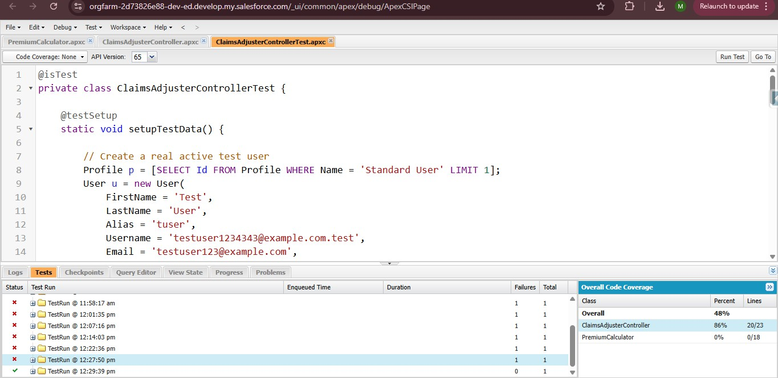

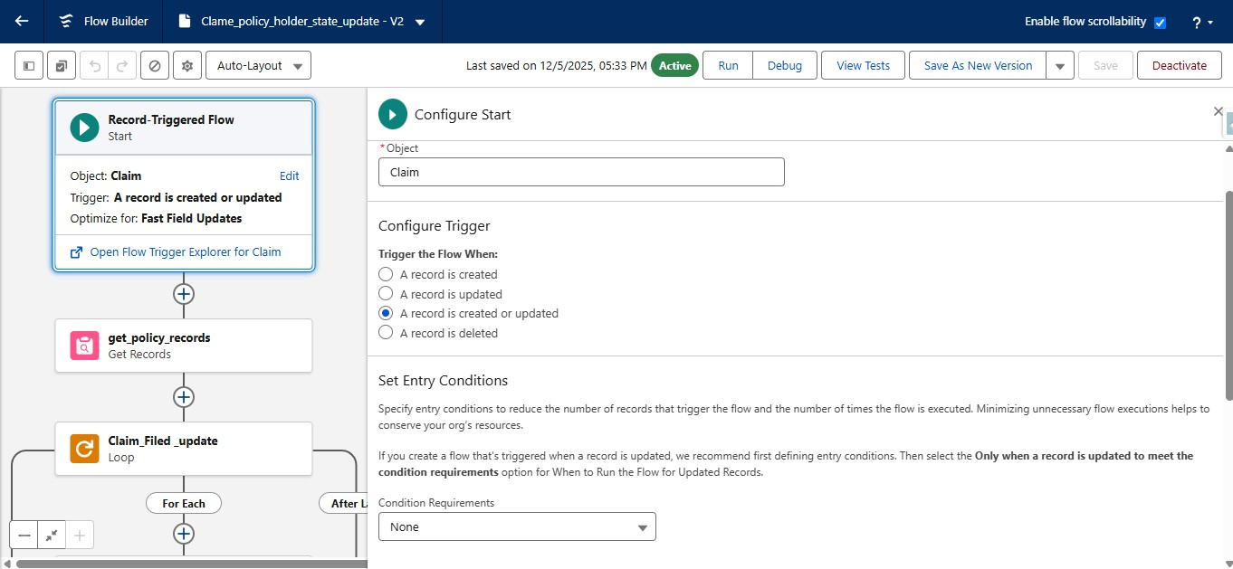

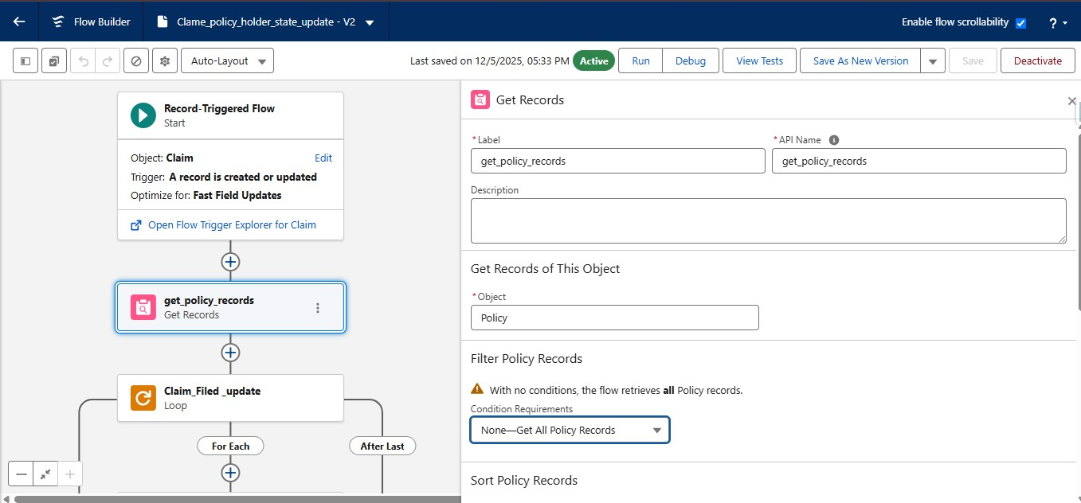

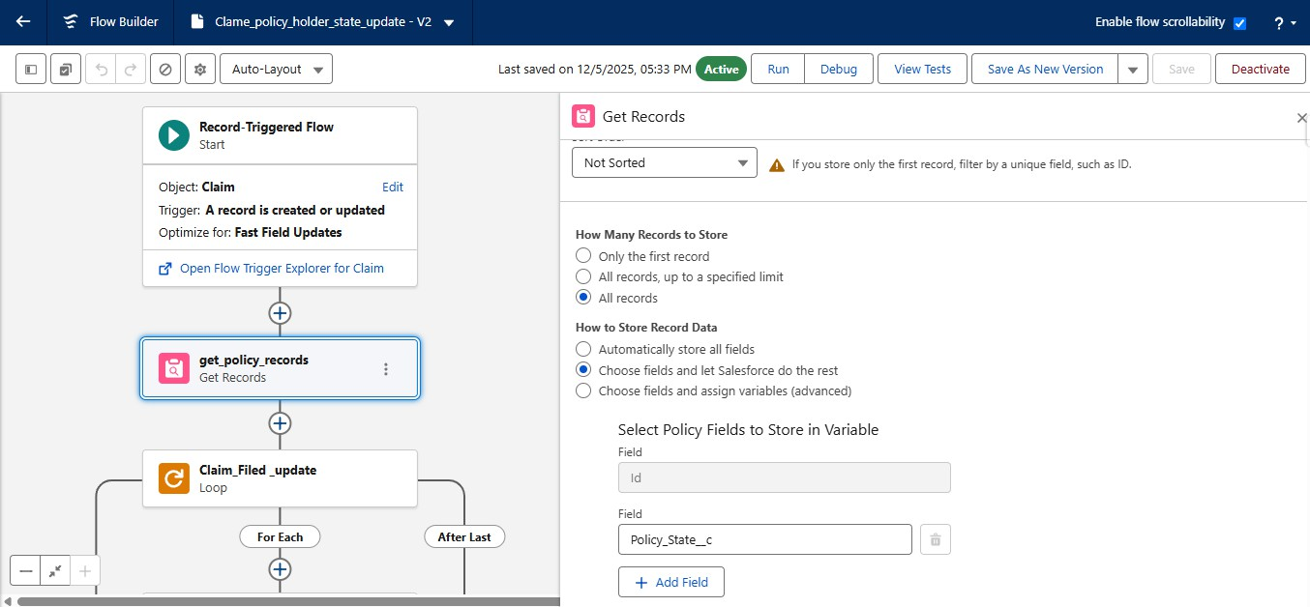

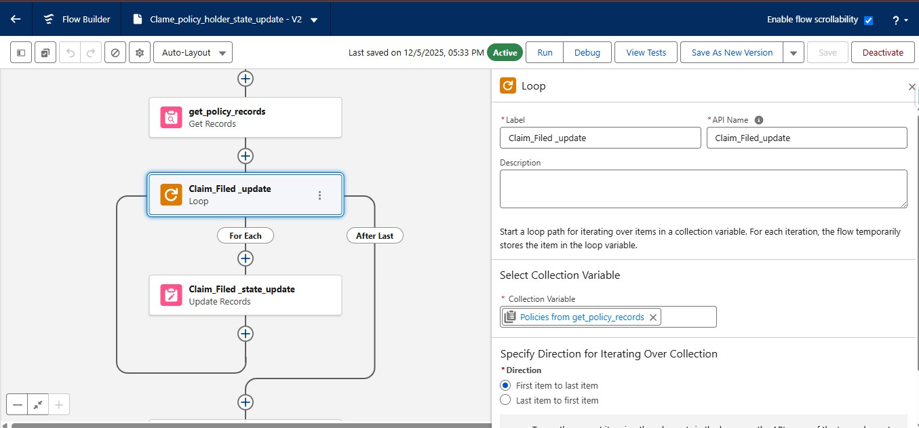

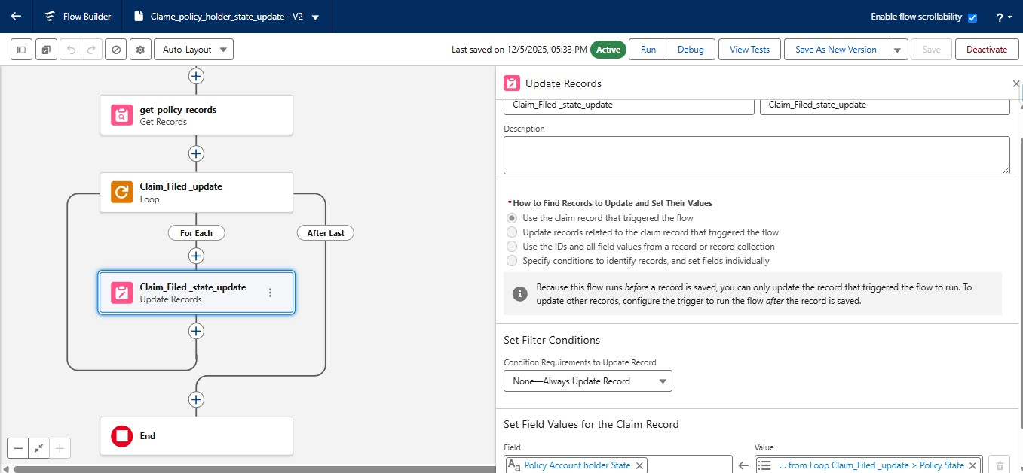

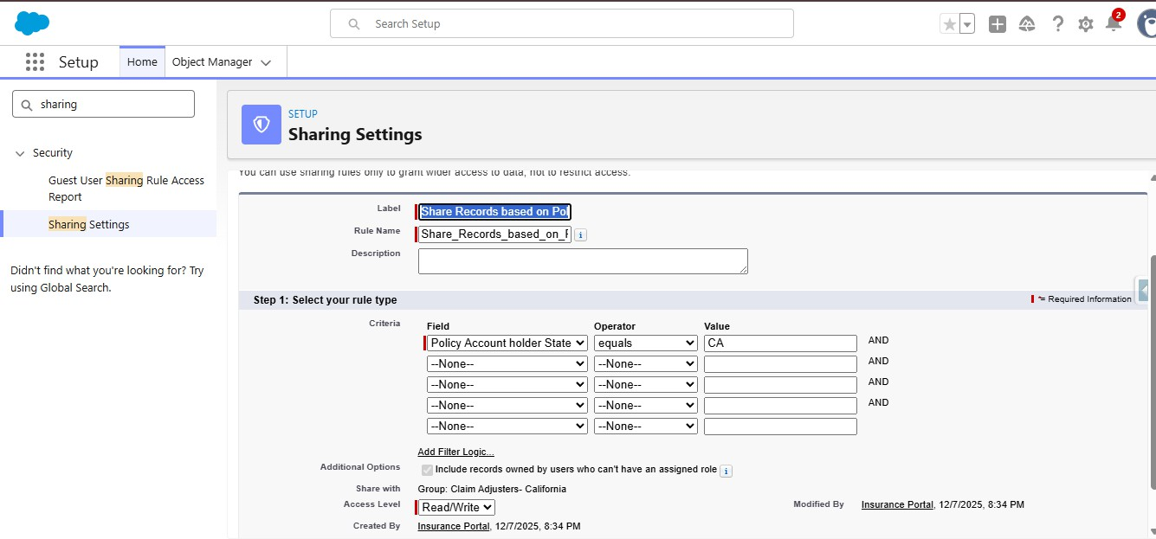

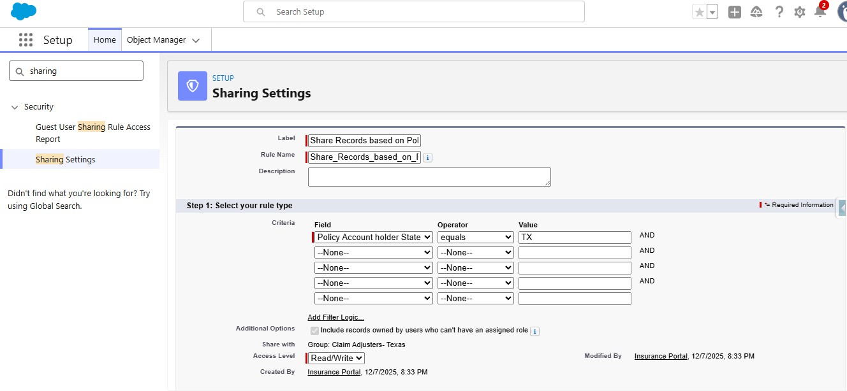

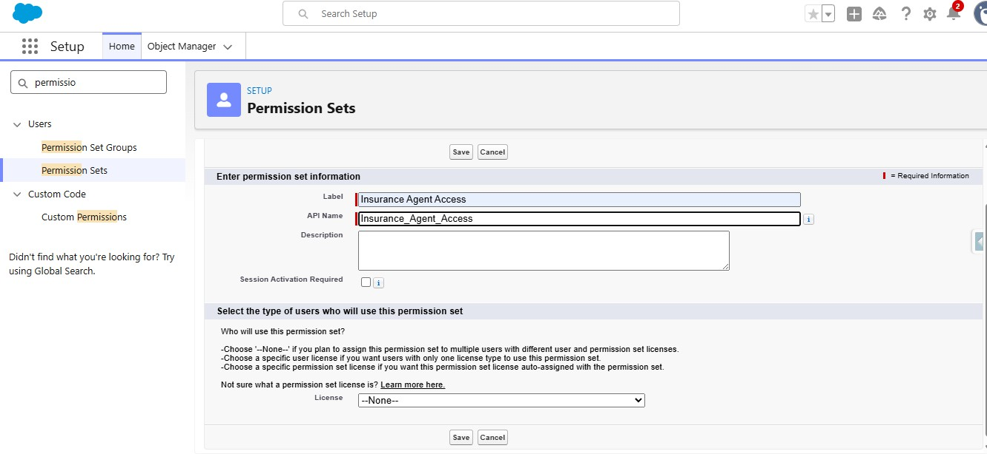

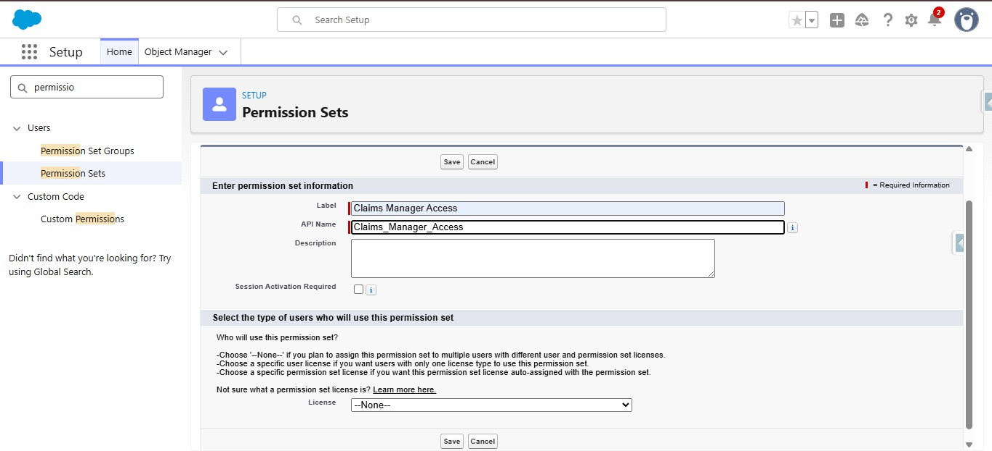

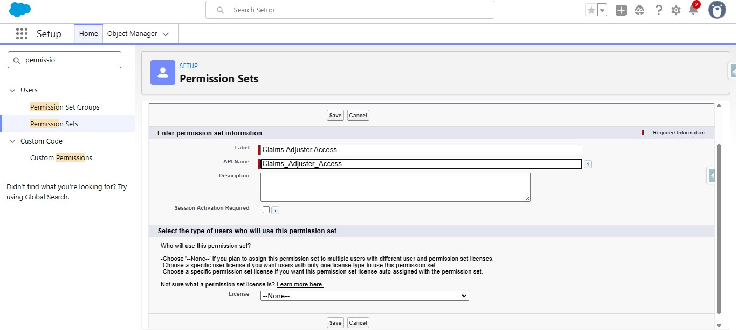

ADVANTAGES &DISADVANTAGES

Advantages
    - Centralizes multiple insurance policies under one customer context.
    - Supports multiple insurance lines in one system.
    - Reduces repetitive policy and claim administration.
    - Automates basic policy and claim validation.
    - Provides a clear claim-status workflow.
    - Provides conversational access through Agentforce.
    - Uses Salesforce records as the operational data source.
    - Can be extended with additional rules, teams and SLA monitoring.

Disadvantages
    - Initial setup requires Salesforce configuration knowledge.
    - Basic validation depends on correctly configured business rules.
    - Complex claim decisions may require manual review.
    - Advanced predictive analytics are not included in the basic implementation.
    - Policy and claim rules must be maintained as requirements change.
    - Large-scale insurance operations may require additional integrations and stronger security controls.

CONCLUSION
The Multi-Line Insurance Policy and Claims Management System demonstrates an end-to-end CRM automation approachformanagingcustomers,multipleinsurancepoliciesandrelatedclaims.ThesystemcombinesSalesforce data structures, Flow-based backend automation and Agentforce conversational interaction. It provides a practical foundationfor centralized policy management, basic claim validation, claim-status tracking and automated handling.
The proposed design can reduce repetitive administrative work and provide more consistent processing. It can also beextendedtowardricherclaimanalytics,workload-awareassignment,SLAmonitoringandmachine-learning-based risk or fraud detection in future implementations.

FUTURE SCOPE
- Add more insurance lines and specialized coverage fields.
- Introduce document upload and automated document verification.
- Add trained machine-learning models for claim risk scoring.
- Use historical claims to identify abnormal or high-risk patterns.
- Add workload-aware assignment across multiple claims teams.
- Implement richer SLA monitoring and escalation notifications.
- Build dashboards for policy distribution, claims, premium and resolution trends.
- Expand Agentforce responses with policy recommendations and next actions.
- Add confidence scores and explanation fields for future AI-based decisions.
- Integrate external payment, document or notification services where required.

Multi-Line Insurance Policy and Claims Management System | Page 13

APPENDIX

Main Salesforce Records
  - Customer
  - Insurance Policy
  - Insurance Claim
  - User
  - Task

Insurance Lines
  - Health Insurance
  - Motor Insurance
  - Life Insurance
  - Property Insurance

Main Flow
Insurance_Policy_and_Claims – Auto-Launched Flow

Agentforce Subagent
Insurance Policy and Claims Assistance

Agentforce Action
Flow-basedInsurancePolicyandClaimsactionwithcustomer/policy/claiminputsandstructuredpolicyandclaim outputs.

Suggested Visuals for Final Project Report
  - Project ecosystem
  - Insurance customer empathy map
  - Solution ideation matrix
  - Customer journey map
  - System requirements model
  - Solution architecture
  - Data model / ER-style diagram
  - Policy and claim automation logic
  - Agentforce conversation flow
  - Development roadmap
  - Functional test coverage
  - Future enhancement roadmap

THANK YOU

Multi-Line Insurance Policy and Claims Management System | Page 14

